

**IPP TECHNOLOGIES WLL**

**And**

**CENTRAL INFORMATICS ORGANIZATION (CIO)**



**Software Requirement Specification (SRS)**

**For**

**Bahrain Locator Mobile, Bahrain – CIO**

***Version 1.2***

**IPP Technologies W.L.L.**

**Suite 33, Building 1144, Road 3020, Block 330,**

**Al Zinj, Kingdom of Bahrain, P.O. Box 65052**

**Tel Direct: 973 77 111 066 / Mob: 973 34145734 / +91 8501047733**

**Authorization**

|  |  |
| --- | --- |
| **Project Code** | BML |
| **Project Name** | Bahrain Locator Mobile |
| **Account** |  |
| **Vertical** | Mobile GIS |
| **Location** | Bahrain |
| **Customer Name** | GIS Directorate, CIO  Kingdom of Bahrain |
| **Program Coordinator/ Email ID** | AkashMunjal / [aakash.munjal@ippcs.com.au](mailto:aakash.munjal@ippcs.com.au) |
| **Project Manager/ Email ID** | KVReddy / [Reddy.karapu@ippcs.com.au](mailto:Reddy.karapu@ippcs.com.au) |
| **Quality Coordinator/ Email ID** | BibhuduttaParija/[Bibhu.parija@ippcs.com.au](mailto:Bibhu.parija@ippcs.com.au) |
| **Customer Contact Information** | Biswatosh Roy, PMP  Head – GIS Projects  GIS Directorate, CIO  Kingdom of Bahrain  # +973 17878233  # +973 36906714  [Biswatosh.ry@cio.gov.bh](mailto:Biswatosh.ry@cio.gov.bh) |

**Document History**

|  |  |  |  |  |
| --- | --- | --- | --- | --- |
|  | **Name** | **Date** | **Role in the Project** | **Signature** |
| **Prepared By** | BibhuduttaParija | 21st April 2014 | QA/BA IPP |  |
| **1st Reviewer** | K V Reddy | 05th May 2014 | PM IPP |  |
| **2nd Reviewer** | Biswatosh Roy | 19th May 2014 | PM CIO |  |
| **Approved by CIO** | Biswatosh |  | PM CIO |  |

**Submission History**

|  |  |  |
| --- | --- | --- |
| **Version** | **Submission Date** | **Media** |
| SRS v1.1 | 13th May 2014 | E-Mail |
|  |  |  |

**Revision History**

|  |  |  |  |  |  |
| --- | --- | --- | --- | --- | --- |
| **Version (x.y)** | **Date of Revision** | **Description of Change** | **Reason for Change** | **Affected Sections** | **Revised By** |
| 1.0 | 5th May 2014 | Initial Version  (Draft) |  |  | Bibhudutta |
| 1.1 | 8th May 2014 | Requirement  Description, Use  Case & QA/QC | Change in requirement | 3.1/1.2/4.0/5.0/6.0 | K V Reddy |
| 1.2 | 19th May 2014 | Section Organization | * Improper Section Organization. * Modification of Functional Requirement Descriptions * Removal of unnecessary sections. * Addition of Requirement Reference | All | Biswatosh Roy |
|  |  |  |  |  |  |
|  |  |  |  |  |  |
|  |  |  |  |  |  |

**Affected Groups**

|  |
| --- |
| Development Team |
| Testing Team |

**List of Reference Documents**

|  |
| --- |
| 1. Use Case |
| 1. Need Assessment Report |
| 1. Technical Proposal submitted by IPP |
| 1. IPP Project Management Plan_CIO V 1.2.1 Final Signed.doc |
| 1. IPPGT_Changecontol_ document_v1.2 13 May 2014.doc |
| 1. Additional Estimation matrix after Need analysis v2.1 Dated 13-05-2014.xls |
| 1. MoM BML- IPP Meeting No 02 - 07-04-2014.doc |
| 1. MoM BML- IPP Meeting No 03 - 08-04-2014.doc |
| 1. MoM BML- IPP Meeting No 04 - 09-04-2014.doc |
| 1. MoM BML- IPP Meeting No 05 - 14-04-2014.doc |
| 1. MoM BML- IPP Meeting No 06 - 20-04-2014 v2.doc |
| 1. MoM BML- IPP Meeting No 07 - 05-05-2014.doc |
| 1. MoM BML- IPP Meeting No 08 - 08-05-2014.doc |
| 1. Generic Requirement - Biswatosh v1.doc dated 14-04-2014 |
| 1. RFP Document Released by CIO (RFP # CIO/I/2013/01/01) |

**PREFACE**

This document is the Software Requirements for the Bahrain Mobile Locator Application Development Project. This document contents all high level Functional & Nonfunctional requirements.

**DEFINITIONS, ACRONYMS, AND ABBREVIATIONS**

| **SL.No** | **Terms** | **Definitions** |
| --- | --- | --- |
|  | CIO | Central Informatics Organization |
|  | GIS | Geographical Information System |
|  | PCV | Project Coordinator Vendor |
|  | PMV | Project Manager Vendor |
|  | PMC | Project Manager Client |
|  | IOS | Internetwork Operating System |
|  | GPS | Global Positioning System |
|  | OS | Operating system |
|  | PP | Project Management Plan |
|  | NAR | Need Assessment Report |
|  | SDD | Software Design Document |
|  | GUI | Graphical User Interface |
|  | BML | Bahrain Mobile Locator |
|  | SQA | Software Quality Assistant |
|  | SRS | Software Requirement Specification |
|  | UAT | User Acceptance Testing |
|  | QA/QC | Quality Assurance & Quality Control |
|  | POI | Points of interest |
|  | SDK | Software development Kit |
|  | Rd | Road |
|  | Blk | Block |
|  | Bld | Building |
|  | UIP | User interactive points |
|  | PIM | Probability Impact Matrix |
|  | PM | Project Manager |
|  | PL | Project Lead |
|  | RFS | Request for Service |

**CONTENT**

1. INTRODUCTION 7

1.1 Purpose 7

1.2 Overview 7

1.3 Product Perspective 7

1.4 Document Organization 8

1.5 Scope 8

1.6 Assumptions 11

2. SYSTEM ARCHITECTURE 12

2.1 System Architecture Diagram 12

2.2 Services Provided by CIO 12

2.3 Development Environment 13

2.4 Deployment Environment 14

3. SPECIFIC REQUIREMENTS 15

3.1 Functional Requirements 15

3.1.1 GIS Based Functional Requirement 15

3.1.1.1 Launching Application 15

3.1.1.2 User Authentication 17

3.1.1.2.1 User Registration 17

3.1.1.2.2 Forget Password 18

3.1.1.2.3 Change Password 20

3.1.1.3 Select Layers 22

3.1.1.4 Generic Search 24

3.1.1.5 Address Search 26

3.1.1.6 Administrative boundary search 29

3.1.1.7 Road search 31

3.1.1.8 POI Search 33

3.1.1.9 Favorite point 34

3.1.1.9.1 Add Favorite point 35

3.1.1.9.2 Edit Favorite points. 37

3.1.1.10 GPS Location 39

3.1.1.11 Buffer search 41

3.1.1.11.1 POI Buffer Search 42

3.1.1.11.2 Favorite Point Buffer Search 43

3.1.1.12 Routing 45

3.1.1.12.1 Routing From Context Menu 45

3.1.1.12.2 Initiate Routing from Buffer panel 47

3.1.1.13 Social Media 49

3.1.1.14 User Feedback 51

3.1.1.15 Map Navigation Tools 53

3.1.2 Generic Mobile Application Based Functional Requirement 53

3.2 External Requirements 56

3.2.1 User Interface Requirements 56

3.2.2 Hardware Interface Requirements 56

3.2.3 Software Interface Requirements 57

3.2.4 Communication Interface Requirements 57

3.3 Performance Requirements 57

3.4 Software System Attribute Requirement 58

4. GRAPHIC USER INTERFACE (GUI) 61

4.1 Launching of application 61

4.2 Select Layer 61

ANNEXURE 63

Annex1 - Requirement Traceability 63

# 

# INTRODUCTION

# Purpose

The purpose of this document is to capture all of the requirements stated by CIO in the system study meetings and those specified in the RFP document. Further, to establish the basis for agreement between the CIO and the IPP on acceptance criteria for the Bahrain Mobile Locator application product. The document contains the complete description of the functions to be performed by the mobile app after the application is deployed.

The CIOshall review the document and give theirs concurrence on the functional requirement. Any omissions, correction or inconsistency in the stated requirements shall be incorporated and resubmitted to the CIO. Once approved by the CIO this document would provide a baseline for design, development, testing and acceptance of the Bahrain Locator Mobile application.

# Overview

People nowadays use the Google maps to find the places and addresses while going to their destinations. Using mobile technologies today citizens extensively exploring the available geospatial data for their routing, alternative routing in transportation and location based services. For which there is a necessity of more accurate data to be provided to the citizen by the government departments.

The GIS Directorate, CIO with a vision to geo-enable society was in a need to develop Locator applications for the latest and trending mobile operating systems like IOS, Android and Blackberry platform supporting all the functions of current web version of the application **(www.bahrainlocator.gov.bh)** plus additional features for mobile including User Favorite Location, Current GPS based Location and Routing Services. It was also expected that the system should support handheld devices like **Smart Phones** and **Tabs** and would be bilingual **(Arabic and English)** in nature

The project includes the development of applications that are capable of running on **Mobile Smart phones** and **Tabs** operating over **Apple’s IOS**, **Google’s Android**, and **BlackBerry OS** and would be bilingual **(Arabic/English)** in nature. The project further includes a **Warranty**, support, and maintenance period of **Six months** following successful implementation, and a period of training for purposes of successfully handing over the applications to the CIO’s team.

# Product Perspective

CIOs Bahrain Locator Mobile is an application which will run on mobile internet. It is a geospatial locator application which will allow users to search and locate Administrative Units, Addresses, Roads, POIs etc. It would also allow users to create route and store their user favourite points for later reference. The application would be integrated with the mobile GPS allowing the users to identify their current position. This application will interact with the Central Data Server of CIO to explore the required information on request and response basis. The developed mobile apps shall be deployed centrally in an application server of CIOs central data for downloads in addition to hosting at Google Play and Apple Apps Store.

Bahrain Locator mobile app shall display the available layers of data in form of maps from CIO’s data server with Legend information. These maps would be provided by CIO as ArcGIS 10.2.1 map services and consumed by the developed application. Routing within the application will be supported by the Routable Road Network Data published by CIO through ArcGIS Server Network Analyst service. The developed applications in turn will present the users with maps and following functionalities.

* Address Search
* Administrative Boundary Search
* Road Search
* Search Point of Interest
* Adding favorite Points
* Search from Favorite Points
* Search from Current GPS Location
* Routing
* Edit Functionality for Favorite Points and attribute information (CIO has to provide the Attribute details)

Figure to be incorporated

# Document Organization

The Specific Requirement described in the document has been grouped into 4 major sections. They are as follows

**Functional Requirements –** This deals with the functional requirements both in terms of GIS functionalities as well as generic mobile application functionalities.A detailed “Use Case” description for all stated functional requirement for Bahrain Locator are covered in the section.

**External Requirements –** This section deals with all interface requirements namely in terms of User Interface, Hardware Interface, Software Interface and Communication Interface.

**Performance Requirements –** This deals with all performance related requirements

**Software System Attributes –** This deals with System Reliability, Availability, Maintainability, Portability, Security etc.

# Scope

The scope of the project’s Application Development Component involvesdesign, development, configuration and deployment of the following apps.

1. Bilingual (English & Arabic) Bahrain Locator Mobile apps for Apple iOS
2. Bilingual (English & Arabic) Bahrain Locator Mobile apps for Google Android
3. Bilingual (English & Arabic) Bahrain Locator Mobile apps for Blackberry

The following items are considered within the scope of development.

1. **Launching Application**
   * User need to accept the term of use.
   * Advertisement/Notification will display if any***(This would be taken up in phase 2 of the project)***
   * User type(RegisterPublic User/Registered CIO User; Non register user)
2. **Select layers** 
   * Normal Base map
   * Satellite imagery
   * Hybrid Map (Satellite Image overlaid with some vector features)

**Note:** - All of the above will be provided as tiled image service

- Option to show Normal Base map Legend

1. **General search**
   * Key Word Search (Generic Search for POIs, Roads, Administrative Units, Address)
2. **Address search (address is identified and validated)**
   * Address located with Map Tips (Bld. No, Rd No, Blk. No etc.)
   * Buffer Search POI from the address
   * Buffer Search favourite points from the address(Only for registered users)
3. **Administrative boundary search (Administrative Unit is identified and validated)**
   * Search by governorate, area & block
   * Search POI inside Governorate, Areas and Block
4. **Road search (Road is identified and validated)**
   * Road Located with Map Tips (Rd Name, Rd No, Area Name etc.)
   * Buffer Search POI from the Road
   * Buffer Search favourite points from the Road. (Only for registered users)
5. **Search points of interest (POI is identified and validated)**
   * Poi Located with Map Tips (Name, Type, Category, Bld. No, Rd No, Blk. No, Area Name etc.)
   * Buffer Search favourite point from the POI. (Only for registered users)
6. **User Authenticated and Non User Authenticated mode.**

* Register user & non resister user
* Display the registration page for registration.
* Email Confirmation for account creation.
* Recall password from registered Email id.

1. **Add favourite points (double tab adds favourite point facility. (Only for registered users)**
   * Create and save user favourite points with identifier and high level locational (administrative) information.
   * Saving Favourites at CIO server location.
   * Modify Favourite Point’s location and attribute.
   * Buffer Search POI from the favourite point.
2. **Current GPS Location**
   * Show Current Location with X, Y
   * Show Block, Area & Governorate and Nearest Road of Current Location
   * Buffer Search POI from the current Location
   * Buffer Search Favourite point from the Current Location. (Only for registered users)
3. **Routing** 
   * Display Route on top of the map
   * Display Driving directions from Source to destination.
   * Switching of Source with destination
   * The various combination of source and destination for routing would include
4. Address to POI and vice versa
5. POI to Favourite Point & vice versa
6. Address to Favourite Point & vice versa
7. Favourite Point to Current Location & vice versa
8. Address to Current Location & vice versa
9. POI to Current Location & vice versa
10. Address to Address
11. POI to POI
12. Favourite Point to Favourite Point
13. UIP to UIP
14. UIP to POI & vice versa
15. UIP to Favourite Point & vice versa
16. UIP to Current Location & vice versa
17. Keyed-in-coordinate to Keyed-in-coordinate
18. POI to Keyed-in-coordinate & vice versa
19. Address to Keyed-in-coordinate & vice versa
20. UIP to Keyed-in-coordinate & vice versa
21. Favourite Point to Keyed-in-coordinate & vice versa
22. Area (Centroid) to Area (Centroid) or POI, UIP, Address, Favourite Point, Keyed-in-coordinate & vice versa.

**13. Synchronized Web Site & Mobile application.**

* + User data will be synchronize with server user database

**14. Bus route Layer**

* + User will switch on & switch off the layer – Switch off by default

**15. Social Media Integration*(Considered in Phase 2 of the project)***

* + Users will be able to share the Map (with route, FP etc) screen shot and Routing Turn by Turn Direction over social media applications installed in the device.

**16. Sharing Link & Sending Feedback by Users *(Considered in Phase 2 of the project)***

* + User will be able to share the download link (Google Play/Apps Store/etc) over social media applications installed in the device.
  + Users will be able to send their feedback in form of a predefined multiple choice questioners to a predefined CIO mail ID

# Assumptions

1. No conversion of data would be required
2. The data schema is in place and will be shared by CIO
3. To geocode the data, it is assume that the data is already populated in feature layers
4. CIO will provide necessary office space and infrastructure for IPP staff to work during onsite project activities
5. CIO has the necessary licenses and setup for ESRI ArcGIS Server Advanced Edition version 10.2.1 and will provide the same during the project for onsite activities.
6. CIO will enable the necessary Market Place Accounts, to host the applications
7. The project duration is for 4 months and post implementation support is for 6 months
8. The project scope is as per the functional requirements provided by CIO and freezed in this Project Management Plan and subsequently in the Requirement Study & Analysis Phase. Any additional requirements would render a change of scope and project duration which need to be mutually agreed by both parties.
9. Hosting of Apps on market places will the responsibility of CIO. However IPP will provide guidance and educate CIO on the process of hosting the application in the market place.
10. Required Content Management development is CIOs responsibility
11. Required Hardware and System Software scalability is CIOs responsibility.: After installation and commissioning of Bahrain locator mobile application whenever the users are increased then usage of system resource is must be high side. To meet the customer satisfaction system resources must be upgraded accordingly.

# SYSTEM ARCHITECTURE

# System Architecture Diagram

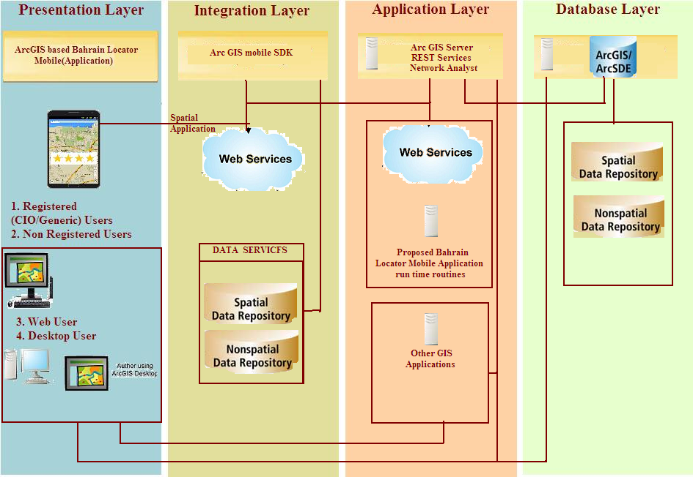

**Presentation Layer**

The presentation layer will be responsible for the delivery and formatting of information to the application layer for further processing or display. It will relieve the application layer of concern regarding syntactical differences in data representation within the end-user systems. The presentation layer will ensure that the communications passing through are in the appropriate form for the recipient. Here in particular the existing systems of CIO will take care about the data maintenance and their existing application mainternance where as IPP will take care about the Baharain Locator mobile application.

**Integration/Business Logic Layer**

This Integration/Business logic layer will be responsible for calling required integrated services from local resources or communicate with the application layer through pre defined web services to perform the action. This layer also ensure to maintain essential data in local SQL lite database to perform business logic validations without effecting the application and data access layer resources.

**Application Layer**

The Application Layer will incorporate the Application Server. This server will be loaded with application and the Arc GIS required mapping services. It will make sure that the other party is identified and can be reached. If appropriate, it will authenticate either the message sender or receiver or both. It will make sure that necessary communication resources exist. It will ensure agreement at both ends about error recovery procedures, data integrity, and privacy.

**Data Access Layer**

The Data Layer will incorporate the various data layers sitting on the preferred Oracle RDBMS. Data access services will be available using connection pooling for retrieving and storing data through Arc SDE services. The data management component ensures that the data is consistent throughout the distributed environment through the use of features such as data locking, consistency, and replication.

# Services to be Provided by CIO

| **#** | **Service Name** | **url** | **Description** | **Remarks** |
| --- | --- | --- | --- | --- |
|  | Mob_Eng_Vec |  | English Vector Map tiled service | Service to be used only for Map representation |
|  | Mob_Eng_Sat |  | English Satellite Map tiles service | Service to be used only for Map representation. Contains Satellite Image with English block no. |
|  | Mob_Eng_Hyb |  | English Hybrid Map tiles service | Service to be used only for Map representation |
|  | Mob_Ara_Vec |  | Arabic Vector Map tiles service | Service to be used only for Map representation |
|  | Mob_Ara_Sat |  |  | Service to be used only for Map representation. Contains Satellite Image with arabic block no. |
|  | Mob_Ara_Hyb |  | Arabic Hybrid Map tiled service | Service to be used only for Map representation |
|  | Mob_Query |  | Query Service | Same for both Arabic & English interface. This would be used for Block, Area, Governorate, Roads, Address and POIs searches and queries. The application would use appropriate fields for English and Arabic interface. This service also contains the Block-Area-Governorate Mapped Flat table to be used for appropriate search dropdown list. A flat table with the various Types & Categories of POIS is also published through this service and to be used wherever required. |
|  | Mob_Eng_Routing |  | ArcGIS Network Analyst dynamic service with Network data configured | For time being the same service would be used for both English & Arabic Interface. At a later stage if CIO could configure Routing as Arabic, a separate Routing Arabic Service would be published which can be consumed by the Mobile apps. |
|  | Fav_Point |  | Feature Access Service (Dynamic) | To be used to store and update Favourite Points. The Schema of the DB and the service configuration will be provided by IPP and then the service would be published by CIO accordingly as desired by IPP |
|  | Loc_User_Man |  | Web Service for User Management. | The Schema of the DB and the service configuration will be provided by IPP and then the service would be published by CIO accordingly as desired by IPP |
|  | Bus_Route |  | Map Service showing Bus Stops and Bus Routes | Same for English & Arabic Interface. |

# Development Environment

* ArcGIS Java Script API &jQuery
* ArcGIS Server 10.2.1

|  |  |  |
| --- | --- | --- |
| **Android** | **IOS** | **Blackberry** |
| Eclipse + ADT plugin | Intel-based Macintosh running Mountain Lion (OS X 10.8.4 or higher) or Mavericks (OS X 10.9) is required. | Eclipse 3.7 classic 32b  Note: Memory requirements should be min -Xmx512M | - XX:MaxPermSize=512m, or more if using profiling. |
| Android SDK Tools | XCode 5 and iOS 7 SDK (or higher) are required to develop applications with ArcGIS Runtime SDK for iOS. | Java SE Development Kit (JDK) 6 32b, update 14 or later |
| Android Platform-tools |  | Windows: Windows XP, Windows 7 (64b or 32b)  Mac: Mac OS X 10.6 Snow Leopard, or Mac OS X 10.7 Lion |
| The latest Android platform |  |  |
| The latest Android system image for the emulator |  |  |
| ArcGIS Runtime SDK for Android |  |  |

# Deployment Environment

All the map, routing and web services would be deployed and published by CIO servers. The deployment environment would beArcGIS Server 10.2.1.

Except for the blackberry, hosting of the application would be at appropriate stores. The blackberry html5 app will be hosted at CIO servers whose configuration and environmental consideration would be provided by IPP at a later stage of the project.

# SPECIFIC REQUIREMENTS

This section provides all the Functional & Non-Functional requirements of the System. It gives a detailed description of the Application and all its features.

# Functional Requirements

This section defines functionalities of the Bahrain Locator Mobil App. These functionalities are structured from the user and system interface perspective. All requirementsmentioned in the proposed RFP and the detailing of those which happened during the User Requirement Study and Analysis has been categorically mentioned below.

# GIS Based Functional Requirement

# Launching Application

This will be a first screen which will display Launching page of the application. While opening the home page following activities need to be performed. User has to accept the terms of use, if user not accepts the terms of use application will get closed.

Application will display a notification message from CIO content management before launching the home page for 3-5 seconds.*(Will be considered in 2nd Phase)*

Use Case Diagram

|  |  |  |  |
| --- | --- | --- | --- |
| Use Case ID: | BML_001 | Req. ID: | **FR 1** |
| Created By: | Bibhudutta | Last Updated By: |  |
| Date Created: |  | Last Updated Date: |  |
| Use Case Name: | Launching Application | | |

|  |  |
| --- | --- |
| Actor: | User |
| Description: | When user will start the Bahrain mobile locator application terms acceptance pop up will be displayed for which user have to accept or reject. |
| Preconditions: | 1. Device should be “on” mode 2. Bahrain locator app must be available on mobile or will be installed from the mobile market/play store. 3. Device should connect to the internet. 4. Device should establish a connection with the server |
| Normal Flow: | 1. Start the Bahrain locator application 2. Device will open the application with term of use. 3. User will accept by tick the check box to continue. 4. Application will display the Advertisement pop up if any. 5. After this pop up user will see the application first page which is the preferred language map interface. |
| Screen Shot |  |
| Alternative Flow: | If user reject the term of use, Application will get close. |
| Business Rules | User has to accept the term of use.  E mail to be validated  Password encryption to be maintained |
| Flow Chat |  |
| Exceptions: | Out of network or poor network coverage area |
| Includes: | Nil. |
| Special Requirements: | At registration form there must be an encouraging note to the user for registration to promote the application. |
| Assumptions: | 1. Notification must be available in the DB. 2. Application should be connecting to the internet. 3. Bahrain locator app must be available in mobile market/play store. |
| Post conditions: | 1. Users can view the map & legend. (Scale 1: 8000) 2. User location shown on the map either through cell network or GPS if the user is within Bahrain territory. 3. If the user opening the map from outside Bahrain then the whole Bahrain Map will come without the user location. 4. If user out of Bahrain and taps on the GPS then the application would alert the user. 5. Provide loading symbol on network issue. |
| Priority: | High. |
| Frequency of Use: | High. |
| Notes and Issues: | Nil. |

# User Authentication

The application would work both in User Authenticated & Non Authenticated Mode. In the Authenticated mode the system should have two groups of user.

**1. Registered Public Users.**

**2. Registered CIO Users.**

Registered CIO user will have additional facilities when compare with Registered Public Users. CIO users would be registered and authenticated the same way a Public User is registered and authenticated. During registration if the user provides a mail ID in the CIO domain ([xx@cio.gov.bh](mailto:xx@cio.gov.bh)), and activates his account by clicking on the link provided in the official mail ID, he would be considered as CIO users with additional privileges in terms of Favourite Point more attribute information input. For all other users who register with valid mail ids other than in CIO domain would be treated as Registered Public Users. . In case of non-register users application will be redirected to home page.–

# *User Registration*

Application should have facility to register the user from mobile device itself, this can be done first time at launch of the application. If user not willing to register it will be redirected to home page. But whenever application open, it will prompt again for registration. it will repeat until registration process completed. However, this is an optional step for the user and user will be informed with advantages of registration.

Use Case Diagram

|  |  |  |  |
| --- | --- | --- | --- |
| Use Case ID: | BML_008 | Req. ID: | **FR 2.1** |
| Created By: | Bibhudutta | Last Updated By: |  |
| Date Created: |  | Last Updated Date: |  |
| Use Case Name: | User registration | | |

|  |  |
| --- | --- |
| Actor: | Public User/CIO User |
| Description: | Application provides facility for user registration. User shall enter his details for registration. User also facilitated with Tell a Friend to share the application below the registration. |
| Preconditions: | 1. Device should be on mode 2. Bahrain locator app must be available on mobile or will be installed from the mobile market/play store. 3. Device should connect to the internet. 4. Device should establish a connection with the server |
| Normal Flow: | 1. Start the Bahrain locator application 2. Click the user registration link. 3. Application will display the registration page. 4. Enter valid data in all text field(Email id, password, Retype password, Mobile number, CPR number) 5. Click on the save button. 6. Application will send an email for conformation. 7. Enter your user id & password& tap on the login button. 8. Application will allow to login. |
| Alternative Flow: | Any network issues user needs to close the application & start again. |
| Business Rules | 1. Email Id will be used for password recovery & user feedback 2. Email id confirmation |
| Flow Chat |  |
| Exceptions: | Out of network or poor network coverage area  Password & retype password is not matching.  Invalid email ID |
| Includes: |  |
| Special Requirements: | Email ID will be treated as User ID  Tell me a friend link to be provided |
| Assumptions: | 1. Server will be facilitated with required services. 2. Bahrain locator app must have registered in mobile market/play store. |
| Post conditions: | Application will register the user & save the user details in the Database. |
| **Priority:** | High. |
| **Frequency of Use:** | High. |
| **Notes and Issues:** | Nil. |

# *Forget Password*

If user forgot password, application will be facilitated with recover the password. User have to enter the registered Email ID & click on forgot password button. Application will send new password to registered Email id. Like standard login page, user should have option for recover password. Both types (CIO & Public of registered users can recover their password in the similar manner.

Use Case Diagram

|  |  |  |  |
| --- | --- | --- | --- |
| Use Case ID: | BML_009 | Req. ID: | **FR 2.2** |
| Created By: | Bibhudutta | Last Updated By: |  |
| Date Created: |  | Last Updated Date: |  |
| Use Case Name: | Forgot Password | | |

|  |  |
| --- | --- |
| Actor: | Public User |
| Description: | User can recover password by click on forgot password link from the login page. Users have to enter registered Email id to get the new password. Application will send new password to the user registered Email id. |
| Preconditions: | 1. Device should be on mode 2. Bahrain locator app must be available on mobile or will be installed from the mobile market/play store. 3. Device should connect to the internet. 4. Device should establish a connection with the server |
| Normal Flow: | 1. Start the Bahrain locator application 2. Click the registered user button. 3. Application will display the login page. 4. Click on the Forgot password link. 5. Enter registered Email id. 6. Click on the Forgot password button. 7. Application will send new password to the registered mail id. 8. Now click on the register user button. 9. Enter your user id & new password. 10. Application will allow to login. |
| Alternative Flow: | Any network issue, user needs to close the application & start again. |
| Business Rules | System has to generate the random password. |
| Flow Chat |  |
| Exceptions: | Out of network or poor network coverage area  Password & retype password is not matching.  Invalid email ID |
| Includes: |  |
| Special Requirements: | Nil |
| Assumptions: | Server will be facilitated with required services.  Bahrain locator app must have registered in mobile market/play store. |
| Post conditions: | Application will send new password to the registered mail id.  Now click on the register user button.  Enter your user id & new password.  Application will allow to login. |
| **Priority:** | High. |
| **Frequency of Use:** | High. |
| **Notes and Issues:** | Nil. |

# *Change Password*

**Application will be facilitated with change password.**

Use Case Diagram

|  |  |  |  |
| --- | --- | --- | --- |
| Use Case ID: | BML_010 | Req. ID: | **FR 2.3** |
| Created By: | Bibhudutta | Last Updated By: |  |
| Date Created: |  | Last Updated Date: |  |
| Use Case Name: | Change Password | | |

|  |  |
| --- | --- |
| Actor: | Public/CIO User |
| Description: | If user click on the change password link application request User to provide the Email id, Old password, new password retype password while change the password. |
| Preconditions: | 1. Device should be on mode 2. Bahrain locator app must be available on mobile or will be installed from the mobile market/play store. 3. Device should connect to the internet. 4. Device should establish a connection with the server |
| Normal Flow: | 1. Start the Bahrain locator application 2. Click on the user profile from context menu. 3. Click on the change password link. 4. Enter Email id, Old password, new password retype password. 5. Click on the change password button |
| Alternative Flow: | Any network issue, user needs to close the application & start again. |
| Business Rules | System has to allow the user to change the password & save the changes to the DB. |
| Flow Chat |  |
| Exceptions: | Out of network or poor network coverage area  Password & retype password is not matching.  Invalid email ID |
| Includes: |  |
| Special Requirements: | Nil |
| Assumptions: | Server will be facilitated with required services.  Bahrain locator app must have registered in mobile market/play store. |
| Post conditions: | Application will changes the password on user request & save the password in DB |
| **Priority:** | High. |
| **Frequency of Use:** | High. |
| **Notes and Issues:** | Nil. |

# Select Layers

After login or without login,application will be facilitated with Bahrain base map at 1:8000 scalewith current location plotted on the map. Users also have the facility to change the layer to Hybrid or Satellite imagery map.

Use Case Diagram

|  |  |  |  |
| --- | --- | --- | --- |
| Use Case ID: | BML_002 | Req. ID: | **FR 3** |
| Created By: | Bibhudutta | Last Updated By: |  |
| Date Created: |  | Last Updated Date: |  |
| Use Case Name: | Select Layer | | |

|  |  |
| --- | --- |
| Actor: | User |
| Description: | By click on the select layer icon, which is available at bottom of the device user can select the hybrid map or satellite imagery map apart from base map. |
| Preconditions: | 1. Device should be on mode 2. Bahrain locator app must be available on mobile or will be installed from the mobile market/play store. 3. Device should connect to the internet. 4. Device should establish a connection with the server |
| Normal Flow: | 1. Start the Bahrain locator application 2. Login as register user or click on the Non Register user 3. Application will display the Bahrain base map. 4. Click on the select layer icon. 5. Select the map base map/satellite/hybrid map layer. |
| Alternative Flow: | Any network issue, user needs to close the application & start again. |
| Business Rules | Nil |
| Flow Chat |  |
| Exceptions: | Out of network or poor network coverage area |
| Includes: | BML_001 |
| Special Requirements: | 1. Display legend with map 2. Provide a loading symbol on network issue. |
| Assumptions: | 1. Server holding various types of data for the use. 2. Server will be facilitated with required ArcGISREST services. 3. Bahrain locator app must have registered in mobile market/play store. |
| Post conditions: | User can view the map layer with 3 different type based on the selection (Base map, Hybrid map, Satellite map) |
| Priority: | High. |
| Frequency of Use: | High. |
| Notes and Issues: | Nil. |
|  |  |

# 

# 

After launching the application, user will view the generic search functionality & Bahrain base map.by entering the valid data into the search text box application will display the search result as a list view or on the map as appropriate.

Use Case Diagram

|  |  |  |  |
| --- | --- | --- | --- |
| Use Case ID: | BML_003 | Req. ID: | **FR 4** |
| Created By: | Bibhudutta | Last Updated By: |  |
| Date Created: |  | Last Updated Date: |  |
| Use Case Name: | Generic Search | | |

|  |  |
| --- | --- |
| Actor: | Public/CIO User (Registered/Unregistered) |
| Description: | When user will start the Bahrain mobile locator application  Application will display generic search with the Bahrain base map. User will enter the valid data to get the result. |
| Preconditions: | 1. Device should be on mode 2. Bahrain locator app must be available on mobile or will be installed from the mobile market/play store. 3. Device should connect to the internet. 4. Device should establish a connection with the server |
| Normal Flow: | 1. Start the Bahrain locator application 2. Enter the valid data for search 3. Click on the search button 4. System will display the search result in the result panel. 5. By click on the result value, application will zoom to feature on the map. |
| Alternative Flow: | Any network issue, user needs to close the application & start again. |
| Business Rules | The search keyword entered in the search text box would be looked up in Administration Layer (Block, Area, Governorate), Road network, POI and Address. Apart from this it should have autocomplete functionality in which after typing the 4 character application should fetch the auto complete list from the server  If search result are >1000 records then showing alert to user to narrow down search |
| Flow Chat |  |
| Exceptions: | Out of network or poor network coverage area  No result found |
| Includes: | BML_001 |
| Special Requirements: |  |
| Assumptions: | Server holding various types of data for the use.  Server will be facilitated with required ArcGIS REST services.  Bahrain locator app must have registered in mobile market/play store. |
| Post conditions: | Application will display the result in result panel & selected result will be highlighted on the map. The details of item in the Result Panel are given below.  Address:  Block No  Road No  Building No  Area Name (English /Arabic)  POI:  POI Name (English /Arabic)  POI Type  Area Name (English /Arabic)  Road:  Road Number  Road Name (English /Arabic)  Road Type  Block Number  Governorate:  Governorate Name (English /Arabic)  Area in Sq. Km.  Area Name:  Area Name (English /Arabic)  Governorate (English /Arabic)  Area in Sq. Km.  Block No:  Block Number  Area Name (English /Arabic)  Governorate Name (English /Arabic)  Area in Sq. Km. |
| **Priority:** | High. |
| **Frequency of Use:** | High. |
| **Notes and Issues:** | Nil. |

# Address Search

Application will be facilitatedwith address search functionality.Users have to provide Building Number, Road No/Name & Block number for address search.All fields are Mandatory.

User has to select either road No or road name. Default will be road No & it will be a numeric text with range between 1 to 5 characters. If user select the road name then app will allow the alphanumeric character in the road name text box with auto complete functionality. The source for this autocomplete text box will be the list of road names fetched from the server. On selection of road name application will display only the highway & avenues name as user start entering the characters in the text box (auto complete).

All text box should be water marked for easy understanding for what have to be typed where.

Block number text field is a free text field range between 1 to 4 characters.

After filling all 3 required parameters to search, result should come in another screen. As the result will always only one so details of the address (need to freeze during schema discussion) shown on the screen available for the address. On tap on the result map screen will come up by zooming the feature on map including a Buffer Search Bar which will cover the Generic Search Bar to give the options for POI &favorite buffer searching.

Use Case Diagram

|  |  |  |  |
| --- | --- | --- | --- |
| Use Case ID: | BML_004 | Req. ID: | **FR 5** |
| Created By: | Bibhudutta | Last Updated By: |  |
| Date Created: |  | Last Updated Date: |  |
| Use Case Name: | Address search by Block, Road & Building | | |

|  |  |
| --- | --- |
| Actor: | Public/CIO User (Registered/Unregistered) |
| Description: | In address search pop up, User have to provide the Block number, Road number/Road Name, Building number. By clicking on the search button,application will zoom to the location & display info. In tag. |
| Preconditions: | 1. Device should be on mode 2. Bahrain locator app must be available on mobile or will be installed from the mobile market/play store. 3. Device should connect to the internet. 4. Device should establish a connection with the server |
| Normal Flow: | 1. Start the Bahrain locator application 2. Click on the menu context & select Address Search. 3. Application will open the address search pop up. 4. User has to enter the Block No, Road No/Name and Building No. 5. By click on the search button application will display map with result |
| Alternative Flow: | Any network issue, user needs to close the application & start again.  Click on the cancel button to cancel the search. |
| Business Rules | 1. On selection of road name application will display only the highway & avenues name as user start entering the characters in the text box (auto complete). 2. Block number text field is a free text field range between 1 to 4 characters. 3. Building text box will allow only alphanumeric character, no special character |
| Flow Chat |  |
| Exceptions: | 1. Out of network or poor network coverage area 2. No result found 3. Too much result found (>1000 records) |
| Includes: | BML_001 |
| Special Requirements: |  |
| Assumptions: | 1. Server holding various types of data for the use. 2. Server will be facilitated with required ArcGIS services. 3. Bahrain locator app must have registered in mobile market/play store. |
| Post conditions: | 1. Application will display the map with searched address. 2. Based on the Language Selection, either English or Arabic Content will be shown as map tips after search   Address:  Block No  Road No  Building No  Area Name (English /Arabic) |
| **Priority:** | High. |
| **Frequency of Use:** | High. |
| **Notes and Issues:** | Nil. |

# Administrative boundary search

Application will be facilitatedwith user to search the administrative units (Governorate, Area and/or block no) by providing the requested inputs. Click on the context menu & select the Administrative search icon. Application will overlap the map page with admin search pop up. Where user need to provide the Governorate**and/or** Area **and/or** block no. By click on the search button application will highlight the search result on the map.

Once the requested parameters selected / filled then user can Click on the search button to search the administrative unit. If query returns more than one record then an intermediate window will appear with a listview which will showing all the results. Here, user can select one record. On selection of admin unit, this intermediate window will swipe with map window and the polygon of selected admin unit will be highlighted on the map including a pop-up window showing the details of the admin unit

Use Case Diagram

|  |  |  |  |
| --- | --- | --- | --- |
| Use Case ID: | BML_005 | Req. ID: | **FR 6** |
| Created By: | Bibhudutta | Last Updated By: |  |
| Date Created: |  | Last Updated Date: |  |
| Use Case Name: | Administrative boundary search | | |

|  |  |
| --- | --- |
| Actor: | Public/CIO User |
| Description: | In administrative search application user to be facilitated with parameters like Governorate, Area and Block number to perform search. |
| Preconditions: | 1. Device should be on mode 2. Bahrain locator app must be available on mobile or will be installed from the mobile market/play store. 3. Device should connect to the internet. 4. Device should establish a connection with the server |
| Normal Flow: | 1. Start the Bahrain locator application 2. Click on the menu context & select Administrative search. 3. Application will open with Administrative search pop up. 4. User has to select the Governorate, Area and enter the block no. 5. By click on the search button application will navigate the user to the search result. |
| Alternative Flow: | Any network issue, user needs to close the application & start again.  Click on the cancel button to cancel the search. |
| Business Rules | Governorate, Area should be dropdown &Block no will be free text.  Area name will display based on the governorate when governorate is already selected from the dropdown. Otherwise all the Area Names would be available in the dropdown  If query returns more than one record then an intermediate window will appear with a listview which shows all the results. Here, user can select one record. On selection of admin unit, this intermediate window will swipe with map window and the polygon of selected.Admin unit will be highlighted on the map including the details of the admin unit. |
| Flow Chat |  |
| Exceptions: | Out of network or poor network coverage area  No result found |
| Includes: | BML_001 |
| Special Requirements: |  |
| Assumptions: | Server holding various types of data for the use.  Server will be facilitated with required ArcGIS services.  Bahrain locator app must have registered in mobile market/play store. |
| Post conditions: | Application will highlight the administrative area with zoom in.  Based on the Language Selection, either English or Arabic Content will be shown as map tips after search  **Governorate:**  Governorate Name (English /Arabic)  Area in Sq. Km.  **Area Name:**  Area Name (English /Arabic)  Governorate (English /Arabic)  Area in Sq. Km.  **Block No:**  Block Number  Area Name (English /Arabic)  Governorate Name (English /Arabic)  Area in Sq. Km. |
| **Priority:** | High. |
| **Frequency of Use:** | High. |
| **Notes and Issues:** | As the reference feature type is type of a polygon so no distance text box for buffer search should be appeared inside Buffer Bar. |

# Road search

Application shall be facilitated with road and highway search options. While searching road information, user must be gave input of road number , road name and block number. In these parameters road number and road name is mandatory and block number is optional. It has been observed that road numbers and road names may repeat in various blocks. In case if user don’t know about his block it can be selected by searching with road number and road name. For this user will be facilitated with list view box for selecting their block number. .. Application also facilitated with Road Name auto fill while entering text in road name text box. As a result map will be displayed with selected road for ready use further to perform action like POI buffer etc., As per Highway data base while searching the road there may a group of segments are identified distinctly. But while displaying the result it has to be shown as one segment only.

Use Case Diagram

|  |  |  |  |
| --- | --- | --- | --- |
| Use Case ID: | BML_006 | Req. ID: | **FR 7** |
| Created By: | Bibhudutta | Last Updated By: |  |
| Date Created: |  | Last Updated Date: |  |
| Use Case Name: | Road Search | | |

|  |  |
| --- | --- |
| Actor: | User |
| Description: | For road search User has to select the “Road Search” icon from the context menu. Application will flash a pop up window, where user has to fill the road no which is by default enable or road name need to click on the radio button to enable & block no which will narrow down the search. By click on the block user will get the block number in the text box |
| Preconditions: | 1. Device should be on mode 2. Bahrain locator app must be available on mobile or will be installed from the mobile market/play store. 3. Device should connect to the internet. 4. Device should establish a connection with the server |
| Normal Flow: | 1. Start the Bahrain locator application 2. Click on the menu context & select Road search. 3. Application will open the Road search pop up. 4. User has to select the road no or road name for search.(Either of these is mandatory) 5. Enter block number (optional) 6. Click on the search button. 7. Application will highlight the road the on the map. |
| Alternative Flow: | 1. Any network issue, user needs to close the application & start again. 2. Click on the cancel button to cancel the search. |
| Business Rules | 1. Block no is an optional field. 2. Road no/name is mandatory field. 3. Road Name will be drop down. |
| Flow Chat |  |
| Exceptions: | Out of network or poor network coverage area  No result found |
| Includes: | BML_001 |
| Special Requirements: | Road name should be as dropdown  Road Number should be auto complete |
| Assumptions: | Server holding various types of data for the use.  Server will be facilitated with required ArcGIS services.  Bahrain locator app must have registered in mobile market/play store. |
| Post conditions: | System should highlight the road on map  Based on the Language Selection, either English or Arabic Content will be shown as map tips after search  Road:  Road Number  Road Name (English /Arabic)  Road Type  Block Number |
| **Priority:** | High. |
| **Frequency of Use:** | High. |
| **Notes and Issues:** | Nil. |

# POI Search

These are all pre-defined Point of Interest areas geographically located and stored as an feature class in database which will be provided by CIO through a service.This functionality facilitates the user to query the POIs based on its type & sub-type.

Use Case Diagram

|  |  |  |  |
| --- | --- | --- | --- |
| Use Case ID: | BML_007 | Req. ID: | **FR 8** |
| Created By: | Bibhudutta | Last Updated By: |  |
| Date Created: |  | Last Updated Date: |  |
| Use Case Name: | POI Search | | |

|  |  |
| --- | --- |
| Actor: | User |
| Description: | POI search will facilitate the user to search the POI by their Type and/or Sub type |
| Preconditions: | 1. Device should be on mode 2. Bahrain locator app must be available on mobile or will be installed from the mobile market/play store. 3. Device should connect to the internet. 4. Device should establish a connection with the server |
| Normal Flow: | 1. Start the Bahrain locator application 2. Click on the menu context & select POI search. 3. Application will open the POI search pop up. 4. Click on the POI icon from the context menu. 5. Application will open the POI type window. 6. Tab the POI type you wish to search. 7. Application will open the POI sub type window. 8. Click on the Search button. 9. Application will display the POI attributes in result panel with any photograph if available. 10. By click on required result, application highlights POI on the map. |
| Alternative Flow: | 1. Start the Bahrain locator application 2. Click on the menu context & select POI search. 3. Application will open the POI search pop up. 4. Click on the POI icon from the context menu. 5. Application will open the POI type window. 6. Enter the Key word. 7. Click on the Search button. |
| Business Rules | If POI type & sub-type is not selected then Key word is mandatory |
| Flow Chat |  |
| Exceptions: | Out of network or poor network coverage area  No result found |
| Includes: | BML_001 |
| Special Requirements: |  |
| Assumptions: | Server holding various types of data for the use.  Server will be facilitated with required ArcGIS services.  Bahrain locator app must have registered in mobile market/play store. |
| Post conditions: | System will display the POI in list view/Map View  Based on the Language Selection, either English or Arabic Content will be shown as map tips after search  POI:  POI Name (English /Arabic)  POI Type  Area Name (English /Arabic) |
| **Priority:** | High. |
| **Frequency of Use:** | High. |
| **Notes and Issues:** | Nil. |

# 

# Favorite point

A favorite point is a point feature which would be stored by Registered Public or CIO users. A FP may be an interested POIs or any place geographically identified.The two groups of users would be provided with different UIs to input different attributes for the FP. CIO users would be provided with options to input addition attributes of the FP as compared to Registered Public users. During operation, the FPs created by the User would be made available to him for search, modification, routing etc. These Favourite Points would be stored as Feature Class at the backend. All favourite point operations would be through a separate ArcGIS service published by CIO. The configuration of the service and the FP database schema would be provided by IPP. The FP backend DB may be used by CIO to update their POI database. However conversion of the FP to POI would be altogether a independent CIO process and has no relation to this project.

# *Add Favorite point*

This option will be available under context menu but disabled for non-registered user. Users have to tap on the map to capture or add FP.Application will also support with attribute window to fill attribute information.

Use Case Diagram

|  |  |  |  |
| --- | --- | --- | --- |
| Use Case ID: | BML_010 | Req. ID: | **FR 9.1** |
| Created By: | Bibhudutta | Last Updated By: |  |
| Date Created: |  | Last Updated Date: |  |
| Use Case Name: | Add Favourite Point | | |

|  |  |
| --- | --- |
| Actor: | Registered Public User/CIO User |
| Description: | Application will facilitate to user to add the favourite point by tap on screen and immediately application will open the attributes window.  For Registered Public Users  The following attribute have to be captured –   1. Name- Mandatory 2. Description - Mandatory 3. Type & Subtype (pick from POI masters) - optional 4. Block Number (auto pick for current location) - mandatory 5. Photo (either through camera or from photo gallery) - optional   For Registered CIO Users  The Following attributes have to be captured –   1. Name English: - Mandatory 2. Name Arabic: - Mandatory 3. Feature Type: POI / Non POI - Mandatory 4. POI Type: (only if Feature Type is POI) - Mandatory 5. POI Subtype: (only if Feature Type is POI) - Mandatory 6. Description: Optional 7. Block No: - Mandatory if POI (May be auto pick from location where it is placed) 8. Road No: - Mandatory if POI 9. Building No: - Mandatory if POI 10. Photo: (Either through Camera or from photo gallery) – Optional   Click on the Add link to add the FP & its attribute to the CIO server. |
| Preconditions: | 1. Device should be on mode 2. Bahrain locator app must be available on mobile or will be installed from the mobile market/play store. 3. Device should connect to the internet. 4. Device should establish a connection with the server |
| Normal Flow: | 1. Start the Bahrain locator application 2. Click on the Favorite Pointfrom the context menu. 3. Click on the desire location on map. 4. Application will open the attribute window. 5. Fill the mandatory attributes field. 6. Click on the add attribute button to add the attribute details to the feature and stored in server. |
| Alternative Flow: | Any network issue, user needs to close the application & start again. |
| Business Rules | Favorite points have to save with respect to user login.  Mandatory fields: FP Name, Description  Optional field: POI type/subtype& photo  Block number will be auto pick for current location.  User can add the FP only for his/her login.  Photo image must be compressed to less than or equal to 1mb. |
| Flow Chat |  |
| Exceptions: | Out of network or poor network coverage area  Fill the mandatory fields. |
| Includes: |  |
| Special Requirements: | While entering the data into the FP attribute, if device get out of coverage area then system will save the data in the session cache & after getting the coverage area device will update the server. |
| Assumptions: | Server holding various types of data for the use.  Server will be facilitated with required ArcGIS services.  Bahrain locator app must have registered in mobile market/play store. |
| Post conditions: | Application will add the attribute details to the server & feature on the map. |
| **Priority:** | High. |
| **Frequency of Use:** | High. |
| **Notes and Issues:** | This functionality is only for the registered user. |

# *Edit Favorite points.*

**Application will facilitate the user to edit the existing FP location & Attribute. Click on the FP on the map. By click on the modify link, application will allow the user to edit the FP attribute & also the location.**

Use Case Diagram

|  |  |  |  |
| --- | --- | --- | --- |
| Use Case ID: | BML_010 | Req. ID: | **FR 9.2** |
| Created By: | Bibhudutta | Last Updated By: |  |
| Date Created: |  | Last Updated Date: |  |
| Use Case Name: | Edit Favourite Point | | |

|  |  |
| --- | --- |
| Actor: | Registered Public/CIO User |
| Description: | Application will facilitate to user to modify an existing favourite point by tap and move on screen.Application also will open an attribute window with existing details on which user can perform modifications. The following attributes has to be displayed  For Registered Public Users   1. Name - Mandatory 2. Description - Mandatory 3. Type & Subtype (pick from POI masters) - optional 4. Block Number (auto pick for current location) - mandatory 5. Photo (either through camera or from photo gallery) - optional   For Registered CIO Users   1. Name English: - Mandatory 2. Name Arabic: - Mandatory 3. Feature Type: POI / Non POI - Mandatory 4. POI Type: (only if Feature Type is POI) - Mandatory 5. POI Subtype: (only if Feature Type is POI) - Mandatory 6. Description: Optional 7. Block No: - Mandatory if POI (May be auto pick from location where it is placed) 8. Road No: - Mandatory if POI 9. Building No: - Mandatory if POI 10. Photo: (Either through Camera or from photo gallery) – Optional   Click on the Add link to add the FP & its attribute to the CIO server. |
| Preconditions: | 1. Device should be on mode 2. Bahrain locator app must be available on mobile or will be installed from the mobile market/play store. 3. Device should connect to the internet. 4. Device should establish a connection with the server |
| Normal Flow: | 1. Start the Bahrain locator application 2. Click on the Favorite Point on the map. 3. Application will open the attribute window. 4. Click on themodify link. 5. Update the attributes data or drag the FP on the map from existing location to new location. 6. Click on the Save button. 7. Application will save updated attribute details to the server and also new feature location on the map |
| Alternative Flow: | Any network issue, user needs to close the application & start again. |
| Business Rules | 1. Application will display the Favorite points based on the user login. 2. Mandatory fields: FP Name, Description 3. Optional field: POI type/subtype & photo 4. Block number will be auto pick for current location. 5. User can add the FP only for his/her login. |
| Flow Chat |  |
| Exceptions: | 1. Out of network or poor network coverage area 2. Fill the mandatory fields. |
| Includes: |  |
| Special Requirements: | While entering the data into the FP attribute, if device get out of coverage area then system will save the data in the session cache & after getting the coverage area device will update the server. |
| Assumptions: | 1. Server holding various types of data for the use. 2. Server will be facilitated with required ArcGIS services. 3. Bahrain locator app must have registered in mobile market/play store. |
| Post conditions: | Application will update the server with the updated attribute details & also the new feature location on the map (If changed) |
| **Priority:** | High. |
| **Frequency of Use:** | High. |
| **Notes and Issues:** | This functionality is only for the registered user. |

# 

# GPS Location

**Application will provide the GPS location functionality to the user. For enabling the GPS user has to double click on the icon. User will find this on the right lower corner of the device. On single click on the GPS icon map should get the centre with showing users current location through an appropriate icon.**

Use Case Diagram

|  |  |  |  |
| --- | --- | --- | --- |
| Use Case ID: | BML_011 | Req. ID: | **FR 10** |
| Created By: | Bibhudutta | Last Updated By: |  |
| Date Created: |  | Last Updated Date: |  |
| Use Case Name: | GPS Location | | |

|  |  |
| --- | --- |
| Actor: | User |
| Description: | By click on the GPS icon application will navigate the user to his/her current location and map represented by an appropriate symbol. On tap of user’s location icon show on the map, system should query for the current Admin area like Governorate, Area, Block& nearest road (maximum up to 100 meter) and show on a info-box. If no road found with-in 100 meter of users location then show appropriate message like “No road found within 100 meters”. |
| Preconditions: | 1. Device should be on mode 2. Bahrain locator app must be available on mobile or will be installed from the mobile market/play store. 3. Device should connect to the internet. 4. Device should establish a connection with the server 5. GPS should be enabling in the device. |
| Normal Flow: | 1. Start the Bahrain locator application. 2. Navigate the map. 3. Double click on the GPS icon to start the GPS. 4. Application will navigate the user to his/her current location. 5. On tap of the current location symbol the application will display the administrative area details in the mapinfo pop up of the current location (Governorate, Area, Block & nearest road). |
| Alternative Flow: | Any network issue, user needs to close the application & start again. |
| Business Rules | Application should navigate to the current location |
| Flow Chat |  |
| Exceptions: | Out of network or poor network coverage area  Fill the mandatory fields. |
| Includes: |  |
| Special Requirements: | If no road found with-in 100 meter of users location then show appropriate message like “No road found within 100 meters”. |
| Assumptions: | Server holding various types of data for the use.  Server will be facilitated with required ArcGIS services.  Bahrain locator app must have registered in mobile market/play store.  Device should have GPS inbuilt |
| Post conditions: | Application will display the administrative area details in the map info pop up of the current location (Governorate, Area, Block & nearest road) |
| **Priority:** | High. |
| **Frequency of Use:** | High. |
| **Notes and Issues:** | Nil |

# 

# Buffer search

**The buffer search bar will come up after doing any search (Address, Road, Admin, FP, POI) and will be common for all. After completion of search application will swipe the generic search panel with buffer panel. User has to provide the buffer zone in meter& by click on the POI or FP application will highlight the POIs or FP on the map.**

# POI Buffer Search

**After any search (Address, Road, Admin, FP, POI) application will display the buffer panel. Enter the buffer distance in meter. On tap on POI buffer search icon, POI type to be open. The buffer distance will be in Meter only and maximum buffer distance is 5000 meter. On tap on search, application should create a buffer for the result feature for given distance and selects all the features of selected type of POI.**

Use Case Diagram

|  |  |  |  |
| --- | --- | --- | --- |
| Use Case ID: | BML_011 | Req. ID: | **FR 11.1** |
| Created By: | Bibhudutta | Last Updated By: |  |
| Date Created: |  | Last Updated Date: |  |
| Use Case Name: | **Buffer Search for POI** | | |

|  |  |
| --- | --- |
| Actor: | User |
| Description: | After any search (Address, Road, Admin, FP, POI) application will display the buffer panel. Enter the buffer distance in meter. On tap on POI icon from the buffer panel application will open the iconic based pop up to select the POI type. Once POI type is get selected application will display the list view of subtype of POIs type. Select the subtype, application will create a buffer around the search result on map & display all the selected POIs. |
| Preconditions: | 1. Device should be on mode 2. Bahrain locator app must be available on mobile or will be installed from the mobile market/play store. 3. Device should connect to the internet. 4. Device should establish a connection with the server 5. GPS should be enabling in the device. |
| Normal Flow: | 1. Start the Bahrain locator application. 2. Make any search (Address, Road, Admin, FPand POI). 3. After search application will display the buffer panel. 4. Enter buffer distance. 5. Select the POI type & subtype. 6. Application will highlight the POIs on the map inside the buffer zone. |
| Alternative Flow: | Any network issue, user needs to close the application & start again. |
| Business Rules | Buffer distance will be in meter.  Maximum distance will be 5000 meter  By click on the back icon application will display the generic search. |
| Flow Chat |  |
| Exceptions: | Out of network or poor network coverage area.  No record found. |
| Includes: | BML_004, BML_005, BML_006, BML_007 |
| Special Requirements: |  |
| Assumptions: | Server holding various types of data for the use.  Server will be facilitated with required ArcGIS services.  Bahrain locator app must have registered in mobile market/play store. |
| Post conditions: | Application will highlight the POIs on the map inside the buffer zone. |
| **Priority:** | High. |
| **Frequency of Use:** | High. |
| **Notes and Issues:** | Nil |

# *Favorite Point Buffer Search*

For this type of buffer search only buffer distance as a parameter will be entered and all the favourites will be highlighted on the map created by the user and found inside the buffer.

Use Case Diagram

|  |  |  |  |
| --- | --- | --- | --- |
| Use Case ID: | BML_012 | Req. ID: | **FR 11.2** |
| Created By: | Bibhudutta | Last Updated By: |  |
| Date Created: |  | Last Updated Date: |  |
| Use Case Name: | Buffer Search for Favorite Point | | |

|  |  |
| --- | --- |
| Actor: | User |
| Description: | This functionality facilitates the user to get his/ her FP by the buffer distance. |
| Preconditions: | 1. Device should be on mode 2. Bahrain locator app must be available on mobile or will be installed from the mobile market/play store. 3. Device should connect to the internet. 4. Device should establish a connection with the server |
| Normal Flow: | 1. Start the Bahrain locator application. 2. Make any search (Address, Road, Admin, FP and POI). 3. After search application will display the buffer panel on top. 4. Enter buffer distance. 5. Click on the Favorite Point icon. 6. Application will highlight the Favorite Point on the map inside the buffer zone. |
| Alternative Flow: | Any network issue, user needs to close the application & start again. |
| Business Rules | Buffer distance will be in meter.  Maximum distance will be 5000 meter  By click on the back icon application will display the generic search. |
| Flow Chat |  |
| Exceptions: | Out of network or poor network coverage area.  No record found. |
| Includes: | BML_004, BML_005, BML_006, BML_007 |
| Special Requirements: |  |
| Assumptions: | Server holding various types of data for the use.  Server will be facilitated with required ArcGIS services.  Bahrain locator app must have registered in mobile market/play store. |
| Post conditions: | Application will highlight the POIs on the map inside the buffer zone. |
| **Priority:** | High. |
| **Frequency of Use:** | High. |
| **Notes and Issues:** | Nil |

# 

# Routing

There will be two gateways to initiate the Routing. The first will be the Standard Routing icon which will be falling under Application Context Menu and another will be from the buffer panel.

For the 1st Gateway of initiating routing through “Application Context Menu”, routing should be possible from any possible combination (Address, Road, POI, FP, UIP, X/Y keyedin and Area) of “Source” and “Destination”.

For the 2nd Gateway of initiating the routing through buffer panel, the current selection will be used as a source. The destination can be selected through appropriate selection popups.

After selecting the Source and destination the user can click on the Get direct button. On doing so the application will display the route on the map with a pop-up showing the Route Summary (total distance of the route as well the time required to travel the distance). It will also bring up on the screen 2 more icon.

**Icon 1 –** Clicking on icon 1 will display the turn-by-turn direction text. User can click the default “Back” button to go back to the map with the route.

**Icon 2 –** Clicking on this icon will allow the user to change the type of route which can be **“Shortest Distance”** or **“Fastest Time”**. By default the route would be calculated based on the “fastest time”. Whenever the user selects the “Shortest Distance” the application would automatically recalculate the route and present it to the user. Accordingly the turn-by-turn direction text would change for the current route.

User can also go back to the UI where he selects “Source” & “Destination” and swipe the source with destination and vice versa and have a reverse route calculated.

# Routing From Context Menu

The standard routing function can be initiated from the context menu. User has to select the route icon from the context menu. Application will open the routing pop up window. User has to select the start point by making the query or tap on the map. Similar manner user has to make the end point. Click on the Get direction button to get the route.

Use Case Diagram

|  |  |  |  |
| --- | --- | --- | --- |
| Use Case ID: | BML_012 | Req. ID: | **FR 12.1** |
| Created By: | Bibhudutta | Last Updated By: |  |
| Date Created: |  | Last Updated Date: |  |
| Use Case Name: | **Routing** From Context Menu | | |

|  |  |
| --- | --- |
| Actor: | User |
| Description: | User will facilitate by the application to find his/her route from Address, Road, POI, FP, Area, UIP, GPS Location, Keyed-in Coordinate |
| Preconditions: | 1. Device should be on mode 2. Bahrain locator app must be available on mobile or will be installed from the mobile market/play store. 3. Device should connect to the internet. 4. Device should establish a connection with the server. 5. GPS should get enabled. |
| Normal Flow: | 1. Start the Bahrain locator application. 2. Click on the routing icon from the context menu. 3. Application will display the routing pop up. 4. Select the search option (Address, Road, Admin, FP and POI) **OR** use the current GPS location **OR** tap the screen to collect UIP **OR**Keyin XY for start point 5. Select the search option (Address, Road, Admin, FP and POI) **OR** use the current GPS location **OR** tap the screen to collect UIP **OR**Keyin XY for end point. 6. After previous operations the application will take the result as start point & end point. 7. Click on the “Get Direction button: to find the route and display on the map along with Route Summary (Total Distance & Time required to travel) 8. Click on Icon 1 (described in Item 3.1.12) to display turn-by-turn direction. 9. Application will display the route details in a new page with direction details. 10. Click on the default “Back” button to go back to the page showing the Map with route. 11. Click on Icon 2 (described in Item 3.1.12) to change routing algorithm. Route will be recalculated. 12. Click on the “Swipe Direction button: to find the reverse route. |
| Alternative Flow: | Any network issue, user needs to close the application & start again. |
| Business Rules | To get the Start point & End point, User has to make a search or tap on the screen (UIP).  Application should display Route along with the driving direction. |
| Flow Chat |  |
| Exceptions: | Out of network or poor network coverage area.  Please select the start point & End point |
| Includes: | BML_004, BML_005, BML_006, BML_007 |
| Special Requirements: | Nil |
| Assumptions: | Server holding various types of data for the use.  Server will be facilitated with required ArcGIS services.  Bahrain locator app must have registered in mobile market/play store. |
| Post conditions: | Application will highlight the rote along with driving direction. |
| **Priority:** | High. |
| **Frequency of Use:** | High. |
| **Notes and Issues:** | Nil |

# *Initiate Routing from Buffer panel*

When user taps on the Routing icon of Buffer bar the Routing window will come and the selected feature of previous window will be set as Source Location. If the userwants to change the selected feature as destination in place of source location then he/she can do it by simply tapping on Swap Button. To select the second point (source or destination) required for routing can be select either through the process described in section 3.1.12.1 or can be achieved through standard search.

Use Case Diagram

|  |  |  |  |
| --- | --- | --- | --- |
| Use Case ID: | BML_012 | Req. ID: | **FR 12.2** |
| Created By: | Bibhudutta | Last Updated By: |  |
| Date Created: |  | Last Updated Date: |  |
| Use Case Name: | **Routing** From Buffer panel | | |

|  |  |
| --- | --- |
| Actor: | User |
| Description: | User will facilitate by the application to find his/her route from the search (Address, Road, POI, FP, Area)or UIP, GPS Location, Keyed-in XY from the buffer panel |
| Preconditions: | 1. Device should be on mode 2. Bahrain locator app must be available on mobile or will be installed from the mobile market/play store. 3. Device should connect to the internet. 4. Device should establish a connection with the server. 5. GPS should get enabled. |
| Normal Flow: | 1. Start the Bahrain locator application. 2. Click on the routing icon from the buffer panel. 3. Application will display the routing pop up with the Source populated with the current Selection. 4. Select the search option (Address, Road, Admin, FP and POI) **OR** use the current GPS location **OR** tap the screen to collect UIP **OR**Keyin XY for end point. 5. After previous operations the application will take the result as start point & end point. 6. Click on the “Get Direction button: to find the route and display on the map along with Route Summary (Total Distance & Time required to travel) 7. Click on Icon 1 (described in Item 3.1.12) to display turn-by-turn direction. 8. Application will display the route details in a new page with direction details. 9. Click on the default “Back” button to go back to the page showing the Map with route. 10. Click on Icon 2 (described in Item 3.1.12) to change routing algorithm. Route will be recalculated. 11. Click on the “Swipe Direction button: to find the reverse route. |
| Alternative Flow: | Any network issue, user needs to close the application & start again. |
| Business Rules | To get the Start point & End point, User has to make a search.  Application should display Route along with the driving direction. |
| Flow Chat |  |
| Exceptions: | Out of network or poor network coverage area.  No record found. |
| Includes: | BML_004, BML_005, BML_006, BML_007 |
| Special Requirements: |  |
| Assumptions: | Server holding various types of data for the use.  Server will be facilitated with required ArcGIS services.  Bahrain locator app must have registered in mobile market/play store. |
| Post conditions: | Application will highlight the POIs on the map inside the buffer zone. |
| **Priority:** | High. |
| **Frequency of Use:** | High. |
| **Notes and Issues:** | Buffer bar will display only after any search. |

# Social Media

Application should facilitate the user to share his/her **map (as screenshots)** with, POIs, FP, route, turn-by turn direction etc. or the **application downloadable link**through the social media. A social media sharing icon would be available which would allow the user to share the map (screen-shot) or the application download link over social media apps (FB, Twitter, You tube &Whatsapp) available in his device.

***Note: Will be considered in Phase 2 of the Project***

Use Case Diagram

|  |  |  |  |
| --- | --- | --- | --- |
| Use Case ID: | BML_013 | Req. ID: | **FR 13** |
| Created By: | Bibhudutta | Last Updated By: |  |
| Date Created: |  | Last Updated Date: |  |
| Use Case Name: | **Social Media Integration** | | |

|  |  |
| --- | --- |
| Actor: | User |
| Description: | User will facilitate to share data through social media. |
| Preconditions: | 1. Device should be on mode 2. Bahrain locator app must be available on mobile or will be installed from the mobile market/play store. 3. Device should connect to the internet. 4. Device should establish a connection with the server. 5. GPS should get enabled. 6. Social media need to install in the device. |
| Normal Flow: | 1. Start the Bahrain locator application. 2. Make any search or routing. 3. Click on the social media icon from context menu. 4. Application will display all the social media icon whichever is available in the device 5. Select the Social media which you wish to send the map screenshot. 6. Application will make a connection to the Social media & post the map |
| Alternative Flow: | Any network issue, user needs to close the application & start again. |
| Business Rules | Application & Social media need to integrate |
| Flow Chat |  |
| Exceptions: | Out of network or poor network coverage area. |
| Includes: | BML_004, BML_005, BML_006, BML_007 |
| Special Requirements: |  |
| Assumptions: | Social media will get installed in the device. |
| Post conditions: | Application will make a connection to the Social media & post your map to the social media. |
| **Priority:** | High. |
| **Frequency of Use:** | High. |
| **Notes and Issues:** |  |

# User Feedback

User will have option to send his feed back to the CIO regarding the application.

***Note: Will be considered in Phase 2 of the Project***

Use Case Diagram

|  |  |  |  |
| --- | --- | --- | --- |
| Use Case ID: | BML_014 | Req. ID: | **FR 14** |
| Created By: | Bibhudutta | Last Updated By: |  |
| Date Created: |  | Last Updated Date: |  |
| Use Case Name: | **Feed Back about Application** | | |

|  |  |
| --- | --- |
| Actor: | User |
| Description: | User will give his/ her feed back to the CIO. |
| Preconditions: | 1. Device should be on mode 2. Bahrain locator app must be available on mobile or will be installed from the mobile market/play store. 3. Device should connect to the internet. 4. Device should establish a connection with the server. |
| Normal Flow: | 1. Start the Bahrain locator application. 2. Click on the Feedback link from the context menu. 3. Select the stars you wish grade the application. 4. Click on the Submit button 5. Application will save the rating to the server |
| Alternative Flow: | Any network issue, user needs to close the application & start again. |
| Business Rules | Nil |
| Flow Chat |  |
| Exceptions: | Out of network or poor network coverage area. |
| Includes: | BML_004, BML_005, BML_006, BML_007 |
| Special Requirements: |  |
| Assumptions: | Nil |
| Post conditions: | Application will make a connection to the Social media & post your status to the social media. |
| **Priority:** | High. |
| **Frequency of Use:** | High. |
| **Notes and Issues:** | Nil |

# Map Navigation Tools

**Req. ID: FR 15.1**

* **Zoom in–** The application should have a zoom in tool for map interaction. This tool will appear when the user tries to interact with the map through swiping. 5 seconds of non-interaction with the map will hide the tool. Apart from this the map can be zoomed in through pinch and drag outward.

**Req. ID: FR 15.2**

* **Zoom Out -** The application should have a zoom out tool for map interaction. This tool will appear when the user tries to interact with the map through swiping. 5 seconds of non-interaction with the map will hide the tool. Apart from this the map can be zoomed out through pinch and drag inward.

**Req. ID: FR 15.3**

* **Pan –** Swiping the map will pan the map at the same scale.

**Req. ID: FR 15.4**

* **North Arrow –** The GPS icon can be pointed towards the North indicating the north direction

**Req. ID: FR 15.5**

* **Scale –** A scale bar should be available and made visible during map interaction. It may disappear when there is no interaction with the map for 5 sec.

# Generic Mobile Application Based Functional Requirement

| **Req. ID** | **Generic Requirement** | **Descriptions** | **Expected Result** |
| --- | --- | --- | --- |
| **FR 16** | Installation | Verify the application can be installed successfully | Application should be able to install successfully |
| **FR 17** | Uninstallation | Verify the application can be uninstalled successfully | User should be able to uninstall the application successfully |
| **FR 18** | Network Test Cases | Verify the behavior of the application when there is a network problem and the user is performing operations  Verify that the user is able to establish data call when the network is back in action | User should get proper error message like “Network Error. Please try after some time.”  User should be able to establish data call when Network is back in action |
| **FR 19** | Voice Call Handling |  |  |
| **FR 19.1** | Call Accept | Verify the user can accept voice call at the time when the application is running and can resume back in the application from the same point | User should be able to accept voice call at the time when the application is running and can resume back in the application from the same point |
| **FR 19.2** | Call Rejection | Verify the user can reject the voice call at the time when the application is running and can resume back in the application from the same point | User should be able to reject the voice call at the time when the application is running and can resume back in the application from the same point |
| **FR 19.3** | Call Establish | Verify the user can establish a voice call in case when application data call is running in the background | User should be able to establish a voice call in case when application data call is running in the background |
| **FR 20** | SMS handling | Verify the user can get SMS alert when the application is running  Verify the user can resume back to the same point after reading the SMS | User should be able to get SMS alert when the application is running  User should be able to resume back to the same point after reading the SMS |
| **FR 21** | Unmapped Keys | Verify that the unmapped keys are not working on any screen of the application. | Unmapped keys should not work on any screen of the application. |
| **FR 22** | Mapped Keys | Verify the mapped keys are functional as appropriately configured with selective functionalities of the application | Mapped keys should function as configured appropriately with selective functions. |
| **FR 23** | Application Logo | Verify that the application logo with the application Name is present in the application manager and the user can select it. | Application logo with the application Name should be present in the application manager and the user can select it. |
| **FR 24** | Splash | Verify that when user selects application logo in application manager splash is displayed  Note the splash do not remain for more than 3 sec. | When user selects application logo in application manager splash should be displayed  Splash should not remain for more than 3 sec. |
| **FR 25** | Low Memory | Verify the application displays proper error message when the device memory is low and exists gracefully. | The Application should displays proper error message when the device memory is low and exists gracefully. |
| **FR 26** | Back Key | Verify that the back key navigates the user to previous screen | The back key should navigate the user to previous screen |
| **FR 27** | End Key | Verify the End Key navigates the user to native OEM screen | The End Key should navigate the user to native OEM screen |
| **FR 28** | Visual Feedback | Verify that there is visual feedback when response to any action takes more than 5 sec. | There should be visual feedback when response to any action takes more than 5 sec. |
| **FR 29** | Continual Keypad Entry | Verify that continual key pad entry do not cause any problem in the application | Continual key pad entry should not cause any problem in the application |
| **FR 30** | Keypad activation | Verify that the keypad is activated whenever user input is required. | Keypad should be activated whenever any input in form of characters is required in the application |
| **FR 31** | Exit Application | Verify that the user is able to exit from the application with every form of exit modes like Flap, Slider, Endkey or Exit options in application and from any point. | User should be able to exit from the application with every form of exit modes like Flap, Slider, Endkey or Exit options in application and from any point. |
| **FR 32** | Charger Effect | Verify that when application is running, inserting or removing the charger do not cause any problem and proper message is displayed when charger is inserted in the device. | When application is running, inserting or removing the charger should not cause any problem and proper message should be displayed when charger is inserted in the device. |
| **FR 33** | Low Battery | Verify that when the application is running and battery is low, then proper message is displayed to the user | When the application is running and battery is low, then proper message should be displayed to the user |
| **FR 34** | Battery Consumption | Verify that the Application does not consume battery excessively | The application should not consume battery excessively |
| **FR 35** | Application Start / Restart | 1. Find the application icon and select it 2. Press a button on the device to launch the app. 3. Observe the application launch in the timeline defined. | The application must not take more than 10s to start |
| **FR 36** | Application Side Effects | Make sure that the application is not causing other applications on the device to fail or hamper. | The application should not cause other applications on the device to fail or hamper |

| **Req. ID** | **Requirements** | **Descriptions** | **Rationale** |
| --- | --- | --- | --- |
| **FR 37** | Download mobile application | A user should be able to download the mobile application through either an application store or similar service on the mobile phone | In order for a user to download the mobile application |
| **FR 38** | Download and notify users of new releases | When a new/updated version or release of the software is released, the user should be intimated automatically. The download of the new release should be done through the mobile phone in the same way as downloading the mobile application. | In order for a user to download a new/updated release. |
| **FR 39** | Search Result in List View | The result of searches to be displayed in a list view wherever appropriate. Details in appropriate requirement description in “GIS Functional Requirement” Section | The way results are displayed in a list |
| **FR 40** | Search Result in Map View | The result of searches to be displayed in the map view wherever appropriate. Details in appropriate requirement description in “GIS Functional Requirement” Section | The way results are displayed in a map |
| **FR 41** | Switch Result View | A user should be able to switch between a map view and a list view for all search options | In order for a user to switch between result views |
| **FR 42** | No match found | If no match is found the user should be informed but kept on the search page in order to get the possibility to conduct a new search right away. | In order for user to conduct a new search if no match is found |
| **FR 43** | Sorting results | Results in list view should be sorted alphabetically | In order for a user to sort results in a list. |
| **FR 44** | Grouping of Results | Result in list views to be grouped as per Feature class or appropriate attribute. | In order for a user to group results in a list. |
| **FR 45** | Filtering results | Filtering of results in Search menus should be done for appropriate. | In order to provide the user flexibility and ease of use and eliminate typing errors. |

# External Requirements

This section provides a detailed description of all the input & output from the system. It also gives a description of Hardware, Software & Communication interface.

# User Interface Requirements

***Req. ID: ER 1***

A first time user of the mobile application should see the login page when he opens the application. Among other thing, this page will provide a link for registration with the note on the benefits of being a registered user. The page should also have a “Skip Registration” button to take him to the map page. Also some option for Language selection should be present.

If the user is not the first time user he would be taken directly to the preferred language Map page through the initial launch screen provided he has earlier logged in through his device and has set his application preferred language.

Also during any time of operation, the user should be able to switch language.

The user interface requirements for other pages have been described in the appropriate Functional requirement items.

# Hardware Interface Requirements

***Req. ID: ER 2***

Since the mobile application is intended to run on **Smart phones** and **Tabs** running on Android, IOs and Blackberry without having a specific designated hardware, it does not have any direct hardware interfaces. However the GPS and Camera system of the device should interface with the application.

# Software Interface Requirements

***Req. ID: ER 3***

The application is intended to run on Android, IOS and Blackberry platform. The application in each of the platform should communicate with the GPS application in the respective device to get geographical information about where the user is located and the visual representation of it. Also the application should communicate with the ArcGIS database published through ArcGIS Services in order to get information about the administrative units, address, roads, POIs and favourite points. The communication between the database and the mobile application consists of both reading and modifying the data as relevant and described earlier in the appropriate sections.

# Communication Interface Requirements

***Req. ID: ER 4***

The communication between the different parts of the system is important since they depend on each other. However, in what way the communication is achieved is not important for the system and is therefore handled by the underlying operating systems

# Performance Requirements

| **Req. ID** | **Generic Performance Requirement** | **Descriptions** | **Rationale** | **Acceptance Criterion** |
| --- | --- | --- | --- | --- |
| **PR 1** | Prominent search feature | The search feature should be prominent and easy to find for the user. | In order to for a user to find the search feature easily. |  |
| **PR 2** | Usage of the search feature | The different search options should be evident, simple and easy to understand | In order to for a user to perform a search easily |  |
| **PR 3** | Usage of the result in the list view | The results displayed in the list view should be user friendly and easy to understand. Selecting an element in the result list should only take one click. | In order to for a user to use the list view easily. |  |
| **PR 4** | Usage of the result in the map view | The results displayed in the map view should be user friendly and easy to understand. Selecting a pin on the map should only take one click. | In order to for a user to use the map view easily |  |
| **PR 5** | Response Time | The fastness of the search | The search should be fast enough so that user does not lose focus | METER: Measurements obtained from 100 searches during testing.  MUST: No more than 5 seconds 100% of the time.  WISH: No more than 2 second 100% of the time. |
| **PR 6** | System Dependability | If the system loses the connection to the Internet or to the GPS device or the system gets some strange input, the user should be informed | In order to make aware of the issue | MUST: 100% of the time |
| **PR 7** | Hard drive space | The application’s need of hard drive space | The application should not consume huge HD space taking a long time to download from the apps Store (at prevalent internet bandwidth) and occupying too much space in devices with limited internal storage. | MUST: No more than 35 MB.  PLAN: No more than 30 MB.  WISH: No more than 25 MB.  MB: DEFINED: Megabyte |
| **PR 8** | Application Functioning | The application also should function when installed in Card and not only in internal storage of the device | In order to make it available for the users having limited internal storage in their devices. |  |
| **PR 9** | Application Memory Usage | The amount of Operate System memory occupied by the application | In order to have the application running in devices with lower configuration. | MUST: No more than 30 MB.  PLAN: No more than 26 MB  WISH: No more than 20 MB  Operate System: DEFINED: The mobile Operate System which the application is running on.  MB: DEFINED: Megabyte. |

# Software System Attribute Requirement

| **Req. ID** | **Attributes** | **Descriptions** | **Meter** | **Acceptance Criterion** | |
| --- | --- | --- | --- | --- | --- |
| **Reliability** | | | | | |
| **SR 1** | System Reliability | The reliability that the system gives the right result on a search provided the Data queried from the services (CIO released) are true and correct. | Measurement obtained from 200 searches during testing | MUST: More than 98% of the searches.  PLAN: More than 99% of the searches.  WISH: 100% of the searches. | |
| **Availability** | | | | | |
| **SR 2** | System Availability | The average system availability when it is used (not considering network failing) | Measurements obtained from 100 hours of usage during testing | MUST: More than 98% of the time.  PLAN: More than 99% of the time.  WISH: 100% of the time. | |
| **SR 3** | Internet Connection | The application should be connected to the Internet in order for the application to connect with the database |  |  | |
| **SR 4** | GPS Connection | The application should be connected to the GPS device in order for the application to get the users location, the map and to calculate the distance |  |  | |
| **SR 5** | Camera Connection | Device Camera should be integrated with the application to allow user to take and store pictures of Favorite Points. |  |  | |
| **Security** | | | | | |
| **SR 6** | Communication Security | Security of the communication between the system and server. The messages should be encrypted for log-in communications, so others cannot get user-name and password from those messages | Attempts to get user-name and password through obtained messages on log-in session during testing. | MUST: 100% of the Communication Messages in the communication of a log-in session should be encrypted.  Communication Messages: Defined: Every exchanged of information between client and server. | |
| **SR 7** | Login Account Security | Security of accounts. If a user tries to log in to the application with a non-existing account then the user should not be logged in. The user should be notified about log-in failure. | Multiple attempts to log-in with a non-existing user account during testing | MUST: 100% of the time. | |
| **SR 8** | User Create Account Security | The security of creating account for users of the system. If a user wants to create an account and the desired user name is occupied, the user should be asked to choose a different user name. | Multiple attempts to create an account with a user name already existing during testing | MUST: 100% of the time. | |
| **Maintainability** | | | | | |
| **SR 9** | Application extendibility | The application should be easy to extend. The code should be written in a way that it favors implementation of new functions particularly if navigation functionality is planned to be implemented in later phase. | Rationale: In order for future functions to be implemented easily to the application | |  |
| **SR 10** | Application testability | Test environments should be built for the application to allow testing of the applications different functions. | Rationale: In order to test the application | |  |
| **Portability** | | | | | |
| **SR 11** | Application Portable in Android Device | In Smart Phone & Tabs having android 2.3 and above |  | |  |
| **SR 12** | Application Portable in IOS Device | In Smart Phones & Tabs having IOS 5.1.1 and above |  | |  |
| **SR 13** | Application Portable in Blackberry Device | In Smart Phones & Tabs having Black Berry 7.1 and above |  | |  |
| **Language** | | | | | |
| **SR 15** | Application Language | The application would have bilingual interface – English & Arabic |  | |  |

# GRAPHIC USER INTERFACE (GUI)

# Launching of application

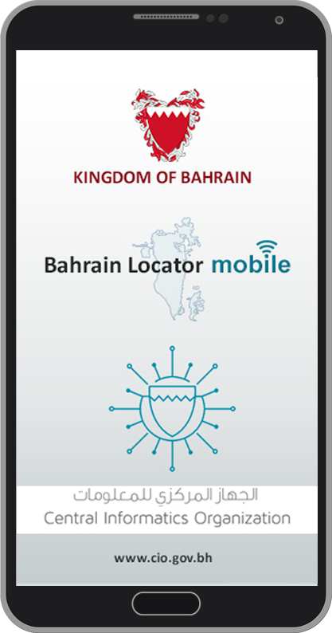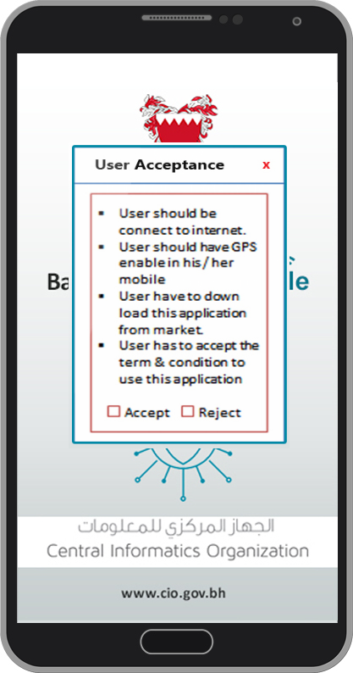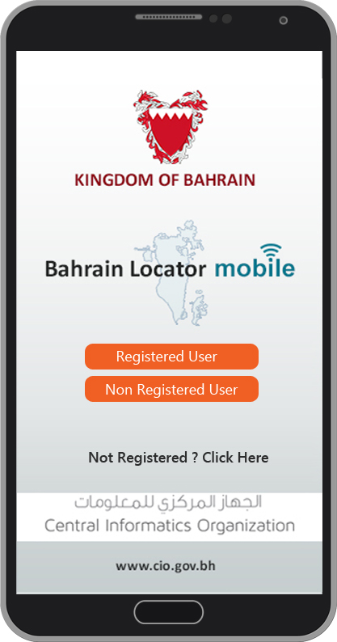

Figure Launching Page Figure Disclaimer Figure User4 Type

# User Authentication

# User Registration

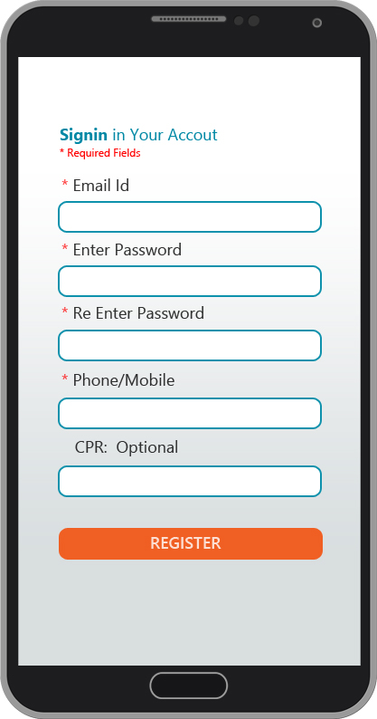

Figure User Registration

# Password Recovery

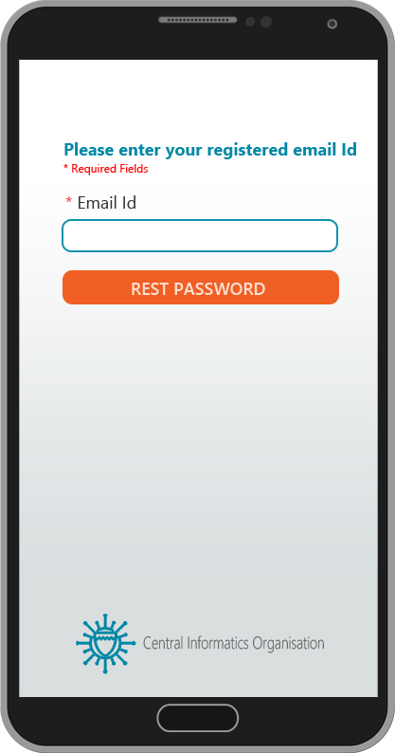

Figure Password recovery

# Change password

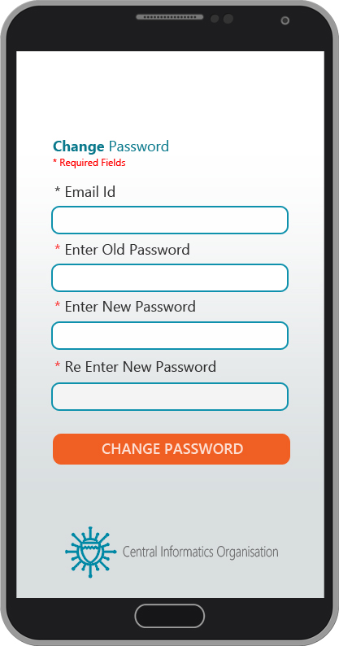

Figure Change Password

**4.2.4 Login User**

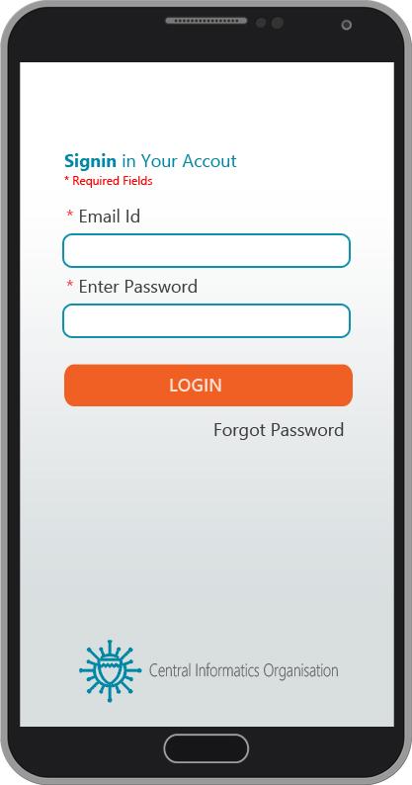

Figure Login Page

**4.3 Select Layer**

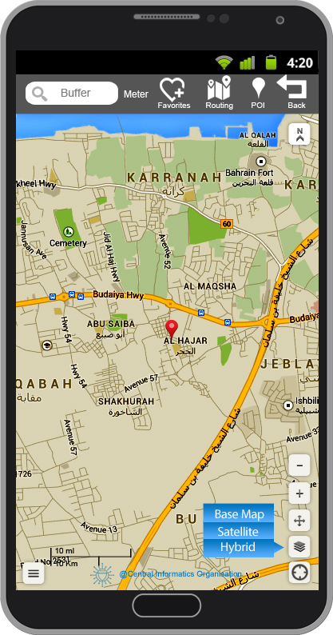

Figure Select layer

**4.3.1 Menu Context**

* Application will display the menu context on right side of the screen
* On tap of Menu Context, A pop up will open & display the menu list.
* Menu will be the icon based menu context.

**Note:** Let us know which style you preferred.

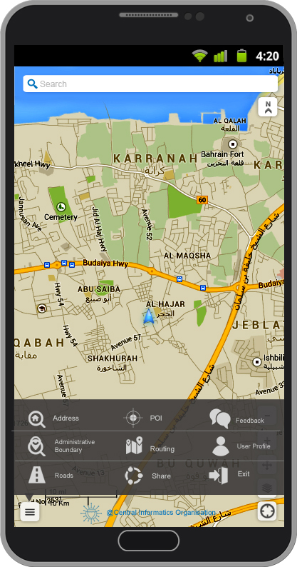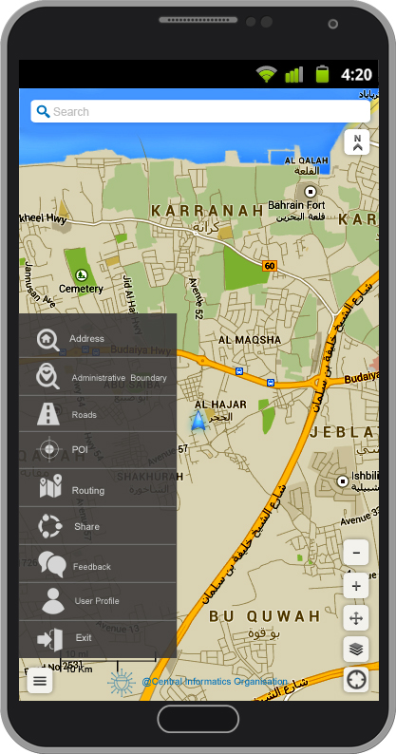

Figure Horizontal Menu Figure Vertical Menu

**4.4 Generic Search**

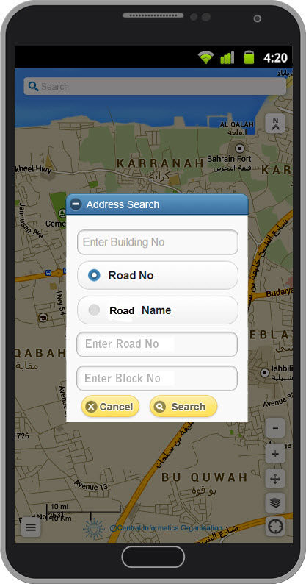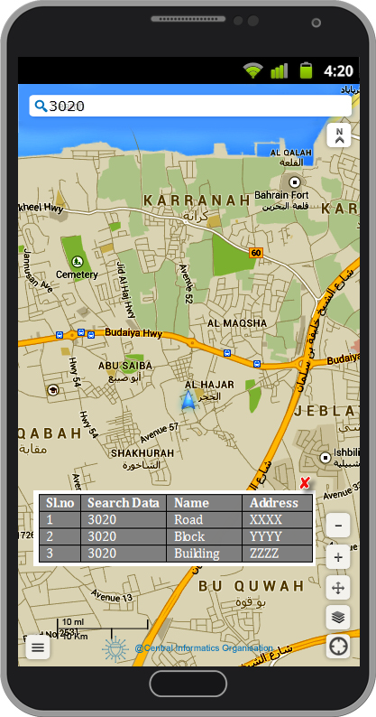

**Figure 11Generic Search Figure 12 Generic Search Result**

* 1. **Administrative Search**

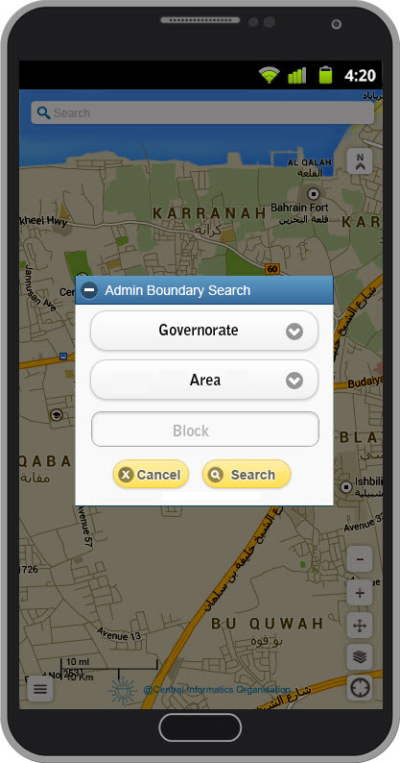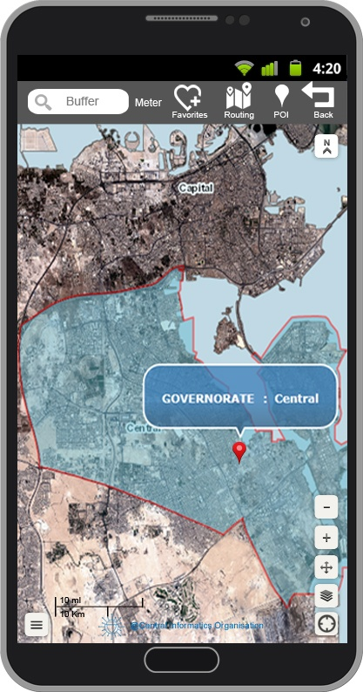

Figure Administrative Search Figure Highlight on Map

* 1. **Road Search**

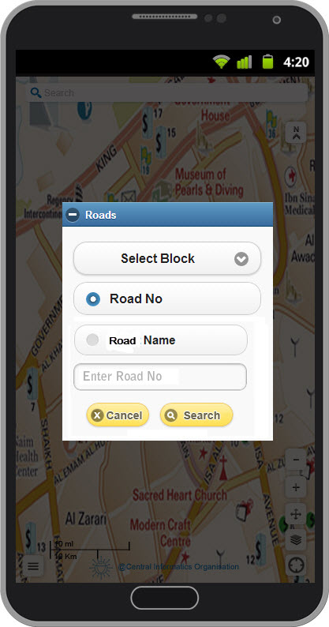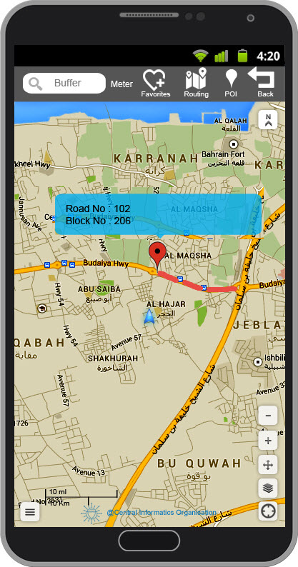

Figure Road Search Figure 16 Highlight on Map

* 1. **POI Search**

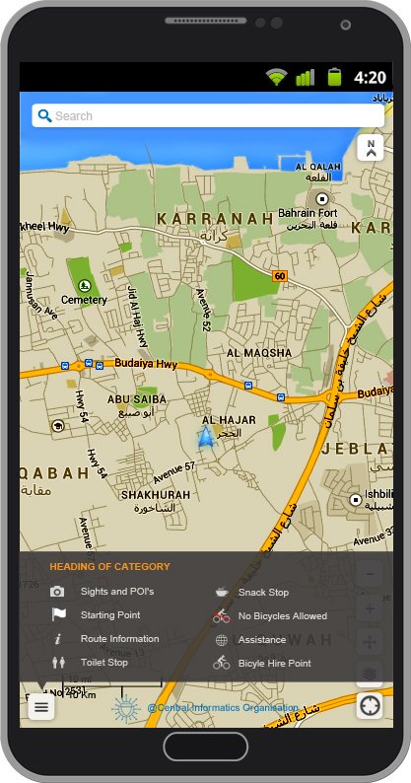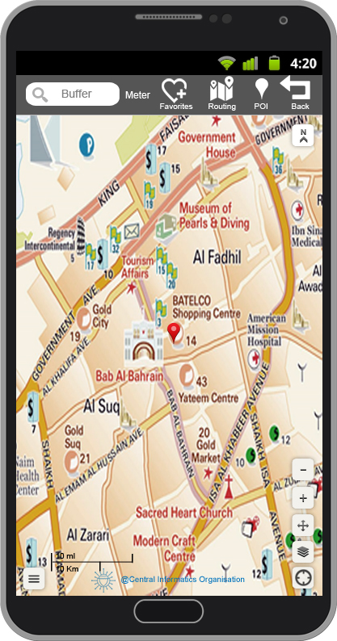

Figure POI Search Figure 18 Highlight on Map

* 1. **Add / Edit Favorite Point**

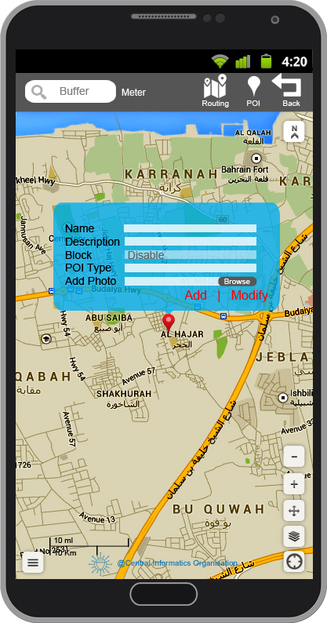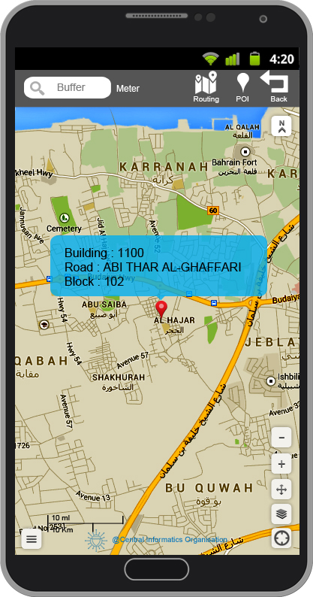

Figure FP Attribute Figure Highlight on Map

* 1. **GPS Location**

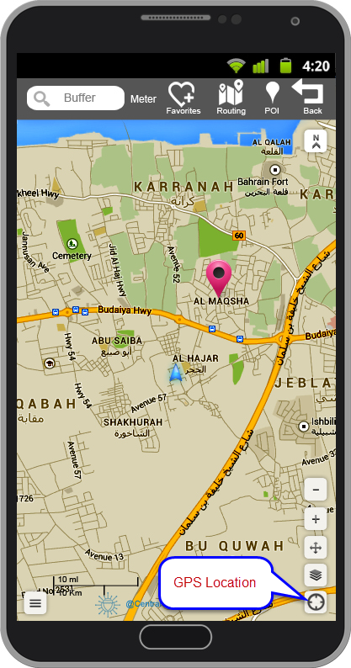

Figure GPS Location

* 1. **POI & FP Buffer**

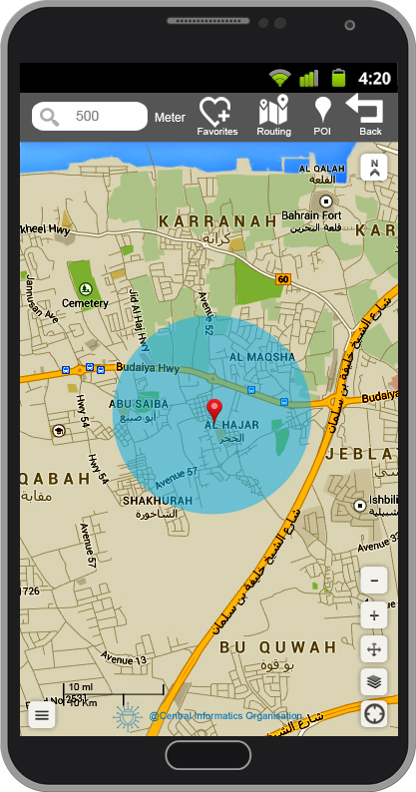

Figure POI & FP Buffer Search

* 1. **Routing**

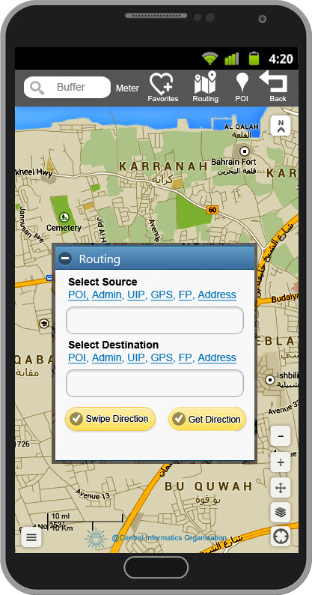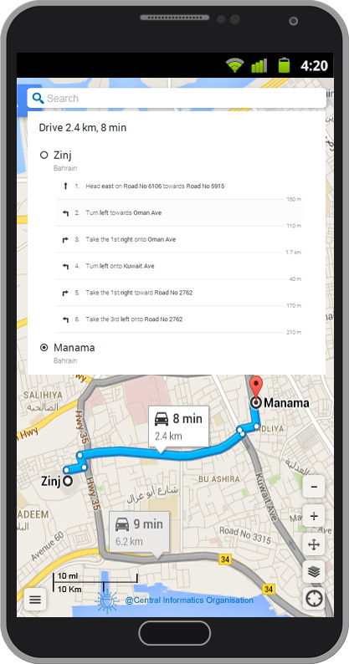

Figure Start point & End PointFigure 25 Highlight On map

* 1. **Social Media**

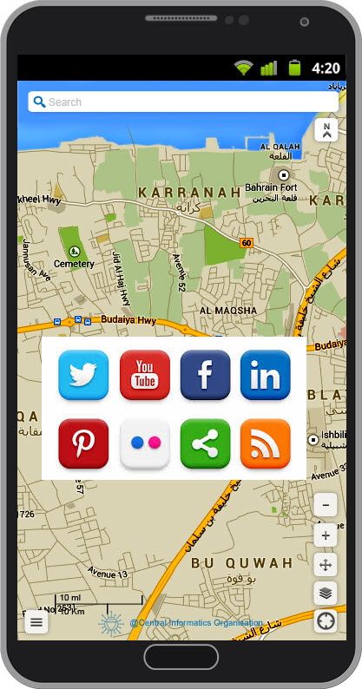

Figure Social Media

* 1. **User Feedback**

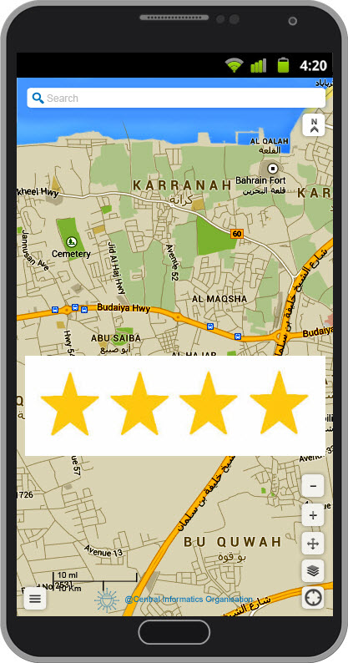

Figure Feedback

* 1. **Map Navigation Tool bar**

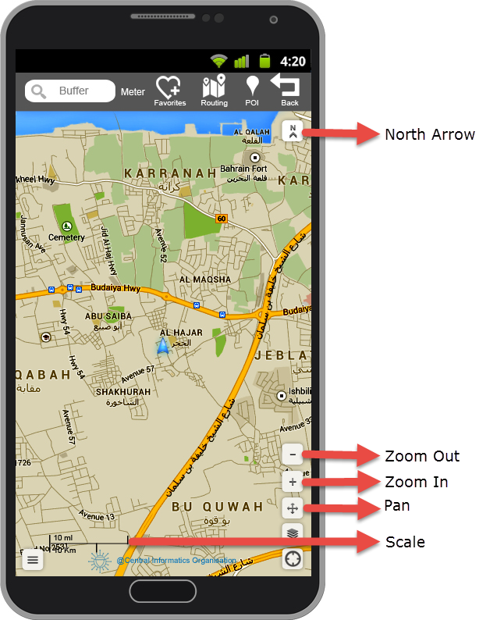

# ANNEXURE

# Annex1 - Requirement Traceability

The Table below shows the references from where the Requirements has been captured

| **Req. ID** | **Requirement Name** | **Reference** | |
| --- | --- | --- | --- |
| **Functional Requirements (FR)** | | | |
| ***GIS Based Functional Requirement*** | | | |
| **FR 1** | Launching Application | | RFP, MOM02 |
| **FR 2.1** | User Authentication - User Registration | | RFP, MOM03, MOM05 |
| **FR 2.2** | User Authentication - Forgot Password | | RFP, MOM03, MOM05 |
| **FR 2.3** | User Authentication - Change Password | | RFP, MOM03, MOM05 |
| **FR 3** | Select Layers | | RFP, MOM02 |
| **FR 4** | Generic Search | | RFP, MOM02 |
| **FR 5** | Address Search | | RFP, MOM02 |
| **FR 6** | Administrative boundary search | | RFP, MOM03 |
| **FR 7** | Road search | | RFP, MOM03 |
| **FR 8** | POI Search | | RFP, MOM03 |
| **FR 9.1** | Favorite point - Add Favorite points | | RFP, MOM03, MOM05 |
| **FR 9.2** | Favorite point - Edit Favorite points | | RFP, MOM03, MOM05 |
| **FR 10** | GPS Location | | RFP, MOM04 |
| **FR 11.1** | Buffer search - POI Buffer Search | | RFP, MOM02, MOM03, MOM04 |
| **FR 11.2** | Buffer search - FP Buffer Search | | RFP, MOM02, MOM03, MOM04 |
| **FR 12.1** | Routing - Routing From Context Menu | | RFP, MOM04, MOM06 |
| **FR 12.2** | Routing - Initiate Routing from Buffer panel | | RFP, MOM04, MOM06 |
| **FR 13** | Social Media Integration (Map Screen Shot & Download Link) | | MOM05, MOM06 |
| **FR 14** | User Feedback | | MOM05, MOM06 |
| **FR 15.1** | Map Navigation – Zoom In | | MOM04 |
| **FR 15.2** | Map Navigation – Zoom Out | | MOM04 |
| **FR 15.3** | Map Navigation – Pan | | MOM04 |
| **FR 15.4** | Map Navigation – North Arrow | | MOM06 |
| **FR 15.5** | Map Navigation – Scale Bar | | MOM06 |
| ***Generic Mobile Application Based Functional Requirement*** | | | |
| **FR 16** | Installation | Generic Req. Doc dated 14-04-14 | |
| **FR 17** | Uninstallation | Generic Req. Doc dated 14-04-14 | |
| **FR 18** | Network Test Cases | Generic Req. Doc dated 14-04-14 | |
| **FR 18.1** | Voice Call Handling | Generic Req. Doc dated 14-04-14 | |
| **FR 18.2** | Call Accept | Generic Req. Doc dated 14-04-14 | |
| **FR 18.3** | Call Rejection | Generic Req. Doc dated 14-04-14 | |
| **FR 19** | Call Establish | Generic Req. Doc dated 14-04-14 | |
| **FR 20** | SMS handling | Generic Req. Doc dated 14-04-14 | |
| **FR 21** | Unmapped Keys | Generic Req. Doc dated 14-04-14 | |
| **FR 22** | Mapped Keys | Generic Req. Doc dated 14-04-14 | |
| **FR 23** | Application Logo | Generic Req. Doc dated 14-04-14 | |
| **FR 24** | Splash | Generic Req. Doc dated 14-04-14 | |
| **FR 25** | Low Memory | Generic Req. Doc dated 14-04-14 | |
| **FR 26** | Back Key | Generic Req. Doc dated 14-04-14 | |
| **FR 27** | End Key | Generic Req. Doc dated 14-04-14 | |
| **FR 28** | Visual Feedback | Generic Req. Doc dated 14-04-14 | |
| **FR 29** | Continual Keypad Entry | Generic Req. Doc dated 14-04-14 | |
| **FR 30** | Keypad activation | Generic Req. Doc dated 14-04-14 | |
| **FR 31** | Exit Application | Generic Req. Doc dated 14-04-14 | |
| **FR 32** | Charger Effect | Generic Req. Doc dated 14-04-14 | |
| **FR 33** | Low Battery | Generic Req. Doc dated 14-04-14 | |
| **FR 34** | Battery Consumption | Generic Req. Doc dated 14-04-14 | |
| **FR 35** | Application Start / Restart | Generic Req. Doc dated 14-04-14 | |
| **FR 36** | Application Side Effects | Generic Req. Doc dated 14-04-14 | |
| **FR 37** | Download mobile application | Generic Req. Doc dated 14-04-14 | |
| **FR 38** | Download and notify users of new releases | Generic Req. Doc dated 14-04-14 | |
| **FR 39** | Search Result in List View | Generic Req. Doc dated 14-04-14 | |
| **FR 40** | Search Result in Map View | Generic Req. Doc dated 14-04-14 | |
| **FR 41** | Switch Result View | Generic Req. Doc dated 14-04-14 | |
| **FR 42** | No match found | Generic Req. Doc dated 14-04-14 | |
| **FR 43** | Sorting results | Generic Req. Doc dated 14-04-14 | |
| **FR 44** | Grouping of Results | Generic Req. Doc dated 14-04-14 | |
| **FR 45** | Filtering results | Generic Req. Doc dated 14-04-14 | |
| **External Requirements (ER)** | | | |
| **ER 1** | User Interface Requirement | RFP, All MOMs | |
| **ER 2** | Hardware Interface Requirement | RFP | |
| **ER 3** | Software Interface Requirement | RFP | |
| **ER 4** | Communication Interface Requirement | RFP | |
| **Performance Requirements (PR)** | | | |
| **PR 1** | Prominent search feature | Generic Req. Doc dated 14-04-14 | |
| **PR 2** | Usage of the search feature | Generic Req. Doc dated 14-04-14 | |
| **PR 3** | Usage of the result in the list view | Generic Req. Doc dated 14-04-14 | |
| **PR 4** | Usage of the result in the map view | Generic Req. Doc dated 14-04-14 | |
| **PR 5** | Response Time | Generic Req. Doc dated 14-04-14 | |
| **PR 6** | System Dependability | Generic Req. Doc dated 14-04-14 | |
| **PR 7** | Hard drive space | Generic Req. Doc dated 14-04-14 | |
| **PR 8** | Application Functioning | Generic Req. Doc dated 14-04-14 | |
| **PR 9** | Application Memory Usage | Generic Req. Doc dated 14-04-14 | |
| **Software System Attributes Requirements (SR)** | | | |
| **SR 1** | **Reliability -** System Reliability | Generic Req. Doc dated 14-04-14 | |
| **SR 2** | **Availability -** System Availability | Generic Req. Doc dated 14-04-14 | |
| **SR 3** | **Availability -** Internet Connection | Generic Req. Doc dated 14-04-14 | |
| **SR 4** | **Availability -** GPS Connection | Generic Req. Doc dated 14-04-14 | |
| **SR 5** | **Availability -** Camera Connection | Generic Req. Doc dated 14-04-14 | |
| **SR 6** | **Security -** Communication Security | Generic Req. Doc dated 14-04-14 | |
| **SR 7** | **Security -** Login Account Security | Generic Req. Doc dated 14-04-14 | |
| **SR 8** | **Security -** User Create Account Security | Generic Req. Doc dated 14-04-14 | |
| **SR 9** | **Maintainability** - Application extendibility | Generic Req. Doc dated 14-04-14 | |
| **SR 10** | **Maintainability -** Application testability | Generic Req. Doc dated 14-04-14 | |
| **SR 11** | **Portability -** Application Portable in Android Device | RFP, Generic Req. Doc dated 14-04-14 | |
| **SR 12** | **Portability -** Application Portable in IOS Device | RFP, Generic Req. Doc dated 14-04-14 | |
| **SR 13** | **Portability -** Application Portable in Blackberry Device | RFP, Generic Req. Doc dated 14-04-14 | |
| **SR 15** | **Language -** Application Language | RFP, Generic Req. Doc dated 14-04-14 | |